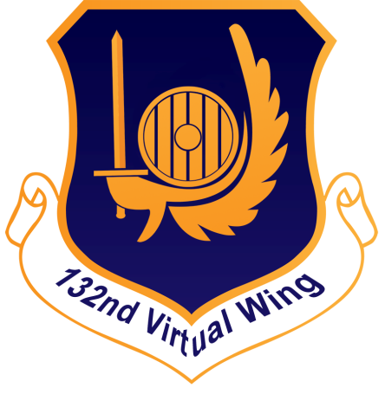

Training Manual

388th Virtual Fighter Squadron

Training Manual

132nd Virtual Wing

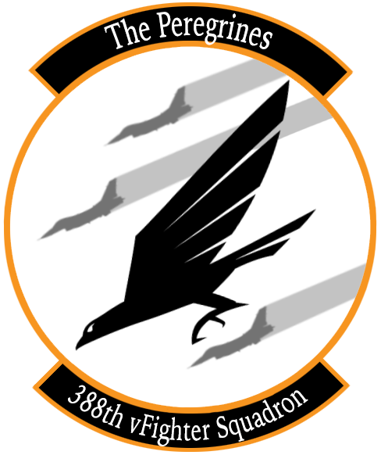

[www.132virtualwing.org](http://www.132virtualwing.org/)

This work is licensed under a[Creative Commons Attribution-ShareAlike 3.0 Unported License](http://creativecommons.org/licenses/by-sa/3.0/).

Training Manual

|  |  |
| --- | --- |
| Applies to: | 388th Virtual Fighter Squadron |
| Type: | Training Manual |
| Version: | 0.4 |
| Published date: | 16.01.2020 |
| Document responsible: | Trollef |
| summary of changes: | Initial Draft |
| rEFERENCES: | * Hamster: 765 IQT Supplement * 185th Multiplayer SOP 3 V1.0 – VFR Formation Flying In Departure, Formation Administration and Recovery * Combatsimchecklist.net: F-16 Multiplayer Formations & Tactical Turns |

Contents

**1.** **INTRODUCTION** 4

2. **INITIAL QUALIFICATION TRAINING**(IQT) 5

2.1 BAS-04: **AIR TO AIR REFUELLING** (SQ) 5

2.3 BAS-05: **PRECISION FLIGHT** (SQ) 11

2.4 COM-01: **THE 132ND WAY OF FLYING** (IP) 19

3. MISSION QUALIFICATION TRAINING(MQT) 36

3.1 TAC-01: **FORMATION AND TURNS** (IP) 36

3.2 TAC-02: **DEFENSIVE SYSTEMS AND MANOEUVRES** (SQ) 52

3.3 TAC-03: **NIGHT OPERATIONS** (SQ) 52

3.4 TAC-04: **AWACS COMMUNICATIONS** (SQ) 52

3.5 SAT-01: **HIGH AND MEDIUM ALTITUDE DELIVERIES** (SQ) 52

3.6 SAT-02: **LOW ALTITUDE DELIVERIES** (SQ) 52

3.7 ACT-01: **ACM 1v1 WVR MANOEUVRING** (IP) 52

3.8 ACT-02: **BVR ENGAGEMENTS AND MUTUAL SUPPORT** (IP) 52

3.9 TAC-05: **MISSION QUALIFICATION TRAINING CHECKOUT** (IP) 52

4. **CONTINUATION TRAINING** (CT) 53

4.1 ACT-03: **DCA CAP** (SQ) 53

4.2 ACT-04: **OCA SWEEP**(SQ) 53

4.3 ACT-05: **OCA ESCORT** (SQ) 53

4.4 SAT-03: **SAT FLIGHT LEAD**(SQ) 53

4.5 SAT-04: **ARMED RECONNAISSANCE**(SQ) 53

4.6 ACT-06: **DCA INTERCEPT**(SQ) 53

4.7 SAT-05: **CLOSE AIR SUPPORT**(IP- CAS INSTRUCTOR) 53

4.8 SAT-06: **SCAR**(SQ) 53

5. **UPGRADES** (UGT) 54

5.1 SAT-07: **FLUG 2-SHIP: OPPOSED SAT** (IP) 54

5.2 ACT-07: **FLUG 4-SHIP: DCA CAP** (IP) 54

5.3 SAT-08: **FLUG 4-SHIP: OPPOSED SAT** (IP) 54

5.4 ACT-08: **MISSION COMMANDER UPGRADE: DCA CAP** (IP) 54

5.5 SAT-09: **MISSION COMMANDER UPGRADE: SAT AI** (IP) 54

5.6 SAT-10: **FORWARD AIR CONTROLLER (AIRBORNE)** (IP- CAS INSTRUCTOR) 54

6. TO BE ADDED LATER 55

**7.** **TERMS** 56

# **INTRODUCTION**

**Scope**: The Training Manual is a supplement to the 132nd wing Standard Operating Procedures (SOP), Tactics, Techniques and Procedures (TTP) and other documents such as the range orders and airfield charts, which are common to all squadrons and air frames, and the 388th SOP and kneeboard pack, which is specific to the 388th and the F-16C.

The Training Manual provides information, context and detail that are not found in the above documents, such as *how* to actually perform a tactical turn or set up the datalink correctly. It follows the Training Programme step by step, and you as a pilot should read and refer to it as you go through the programme.

This should also save you from having to research a lot of material on your own, as we have already compiled this document with information about how to perform most tasks in the jet, and within the flight, all within the context of the squadron’s standard operating procedures.

Note that this document does not describe every track in the training programme. Weapons, avionics and similar that are not specific to the 132nd should be learned from other sources, such as the flight manual provided by Eagle Dynamics.

The Training Manual also sets out the *expectations* of the 132nd Virtual Wing to a pilot in the Peregrines, by providing a clear baseline for what we expect you to be able to do at each point in the training programme, and of course afterwards as a mission qualified pilot.

We hope this document will be some help in preparing you to fly with the 388th “Peregrines” Virtual Fighter Squadron.

**Pilot responsibility**: Use common sense

* SOPs describe standardised *procedures* for routine operations.
* TTP’s describe *techniques* that can be used in different situations.

Neither are substitutes for common sense and judgment, nor they represent the sum of all experience. You’ll make a few new experiences on your own or find yourself in a situation the SOP or TTP’s do not describe. It is the pilot's responsibility to fly the aircraft safely and effectively in all circumstances, as required to accomplish the overall mission.

Weapon, sensor and avionics mechanics and operational descriptions are not covered here, nor is air and ground vehicle recognition. I.e. we won’t tell you how a radar works or what a BMP looks like, but will have an expectation that you find this hobby interesting enough to learn new things.

**Recommended changes**: Improvements and recommended changes to this SOP should be stated to the parties nominated in the Document Responsible section above.

# **INITIAL QUALIFICATION TRAINING**(IQT)

## BAS-04: **AIR TO AIR REFUELLING** (SQ)

Air- to- air refuelling (AAR) is a critical skill to master. It should be conducted regularly by any pilot, outside of the regular hosted training- and combat events if need be, in order to maintain proficiency. Familiarisation with the procedures outlined below is essential in order to be able to conduct safe and efficient aerial refuelling operations in a multiplayer environment.

The following explains how AAR is conducted in the 132nd Virtual Wing. There are no squadron- specific SOP’s for AAR, because several aircraft types use the same tanker types. This means that in a mission, you can find yourself on the tanker with any other aircraft capable of refuelling from a boom (as opposed to the drogue used by the F/A-18 and F-14), such as the F-15C and A-10C. With the A-10C in particular, different tankers are usually available due to the difference in preferred refuelling airspeed and altitude between the types.

Note that AAR begins on the ground, with mission preparation. Fuel is a very scarce resource in the F-16, and fuel considerations will be an important factor in any mission planning. As a minimum, the pilot should familiarise himself with the tanker information provided through the Mission Data Card (MDC): Callsign, TACAN, radio frequency and altitude, and also the location of the tanker track.

You will most often take fuel from a KC-135.

TIP: When planning a mission, it is a good idea to place a waypoint in the middle of the tanker track in order to provide you with real-time information about your ability to refuel from your current location in the most optimal manner using the ICP CRUS TOS and RNG subpages.

Tankers will typically fly the following “contract":

* + 40- 50nm racetrack pattern
  + Mach 0.6 (around 300KCAS)
  + Turns at X degrees of bank

Before refuelling, MASTER ARM shall be set to OFF and lights set according to SOP or Flight Lead’s instruction.

**AAR IN FIVE STAGES:**

1. **RENDEVOUZ**

*Communications and deconfliction*

When the Flight Lead makes the decision to head for the tanker, he will coordinate with the controlling agency and push the flight to the tanker frequency at an appropriate distance from the tanker, normally about 10- 15nm.

Note that the tankers normally operate on VHF in order to enable the flights to monitor the AWACS nets on UHF while on the tanker. This means that you will use the tanker frequency as your internal frequency. There may be other flights on the same frequency, so keep use brevity and keep chatter to a minimum.

Flight Lead will check in on the tanker frequency, typically with the following:

* Number and type of aircraft (“Viper is two times F-16…)
* Position (“inbound TEXACO from the North, FL190, 20 miles”)
* Lowest fuel state in the flight (“fuel six eight”, meaning 6800lbs)

This is an informative call to other flights. If there is another flight inbound, the flight with the least fuel refuels first unless the others mission is more time critical. The flight leads will coordinate deconfliction.

If there is another flight already on the tanker, you’ll hear something like: “Copy Viper, this is SPECTER1, two times chicks in tow.” (Other flights that are in formation with the tanker (stages 2 through 5 below) are referred to as “chicks in tow”.)

Call out any positions you are in, and any intentions to shift positions, for example:

* “Two established left observation.”
* “One moving pre-contact.”

*The rendezvous:*

Because the tanker is anchored in a racetrack, the fighter has to come to the tanker. This means there’s a bit of geometry involved. For **low-aspectrendezvous**(i.e. if you’re chasing the tanker), it is relatively straightforward:

* Configure the jet according to the AAR checklist.
* Approach at the tanker’s designated altitude *minus* 1000ft.
* Gradually reduce overtake.

This means that if the tanker is at FL200, you approach at FL190 until you are visual with the tankerand ready to join the left observation position or, if cleared to do so, the pre-contact position.

The 388th contract speed is 350KCAS or M0.8, whichever is lower, so you will have about 50 knots overtake on the tanker. Reduce this gradually as you approach, but also be careful not to spend excessive amounts of time crawling up on the tanker. You can use the radar closure rate in STT mode and TACAN readout to judge your rate of closure.

For **high- aspect rendezvous**, we use the “fighter turn-on” technique.This is a real-life technique designed to provide a standardised and effective method for joining on the tanker:

* Turn towards the tanker when it is at 35° relative bearing and 15nm distance.
* Turn using the standard 30° of bank and 350KCAS energy sustaining turn. (See chapter 3.1. for a cockpit reference for 35°.)
* The tanker should be at 4.5nm at 7° relative bearing, and you should exit the turn 2.5nm in trail of the tanker.
* At this point, you’re on a low-aspect rendezvous as described above.
* For a more aggressive rendezvous, start the turn earlier, but only after passing the tanker.
* You can switch to DGFT or MSL OVRD to quickly re-gain radar lock if it is lost during the turn.
* Open the refuelling door 3-5 minutes before joining on the tanker, in order to let the tanks depressurise fully before taking fuel. At the same time, set your DED repeater on the HUD and bring up the BINGO page to see your current fuel on the HUD while refuelling.
* Make sure you are stable and stick natural when opening the refuelling door, because this will switch the flight control system to landing gains mode with increased sensitivity to assist with AAR.
* Note that centreline tanks do not top up completely even if properly depressurised.

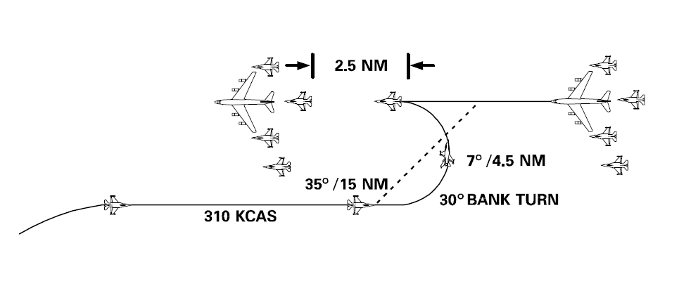

Figure 1: The Fighter Turn On

1. **LEFT OBSERVATION**

The 132nd Wing uses a “left to right” refuel pattern, where flights anchor to the tanker on the left side, refuels in sequence and then anchors on the right side of the tanker when done. Formally, this is called the “observation position”, however, we prefer to use left and right observation to avoid any confusion.

The aircraft with the least fuel will as a rule refuel first. In many cases, this will be the wingman, because he typically burns more fuel in order to re-join and maintain formation with the flight lead. If there is no other flight on the tanker, the aircraft with the least fuel will in many cases move straight into the pre-contact position in order to save time, however, the flight lead should keep the wingman in formation until established in the left observation position if and as required for deconfliction, particularly with inexperienced wingmen. Regardless:

* Only move to left observation or pre-contact when cleared to do so by flight lead.
* Once in the left observation position, all subsequent positions are flown referencing the tanker (not other aircraft in the flight). This is in order to allow the receiving aircraft freedom of movement around the pre- contact position.
* If there’s more than one aircraft in the left observation (or right), only the innermost aircraft references the tanker; other aircraft reference the next aircraft.
* Be careful to maintain a constant distance, particularly if there are other aircraft in the observation position.
* Align the tanker’s wingtip with the tanker’s cockpit window.
* Maintain at least one wingspan’s distance.

Note that if you’re training, the instructor pilot may fly aft of the proper position in order to be in a better position to observe.

1. **PRE-CONTACT**

Pre-contact is a position slight aft and centre of the contact position, where you stabilise the jet for contact.

* Reduce throttle slightly to move the aircraft back from the left observation, then flow gently into the pre-contact position:
* The pre-contact position should be slightly below the boom, centred, and about the length of your jet aft.
* Stabilise speed and attitude, and give the “ready pre-contact” radio call.
* When cleared by the boom operator, ease forward to the contact position.

At this point, you’ll be looking through the HUD. It may be tempting to use the HUD elements or HUD frame as a reference because of the lack of a canopy bow in the F-16, particularly if you’re used to a canopy bow for positional referencing. Our advice however, is to fly off the actual tanker *just like you did in the left observation*, instead of suddenly starting to use the HUD as a reference just because you switched position.

For example, if there is a sidewind, there will be an offset between your gun cross and flight path marker unless you’ve remembered to enable the drift cut-off, making it difficult to use HUD elements as constant or absolute references. Keep it simple, use Mk.1 eyeball and practise. The Viper is actually quite easy to refuel compared to many other jets: the boom keeps you stable, the throttle is responsive and you have great visibility.

1. **CONTACT**

The contact position is where the boom connects to your jet, and you take fuel.

* When cleared by the boom operator, flow forward slowly using gentle throttle input (1-2% should be enough).
* Either reference the yellow centre line and let the boom pass directly over you, or offset slight to the left and let it pass slightly high and left.*
* Once past the boom, follow the director lights to maintain the correct position.
* Monitor the fuel quantity to disconnect at the pre-briefed value if not topping off 100%, and to anticipate the disconnect if taking a full fuel load.

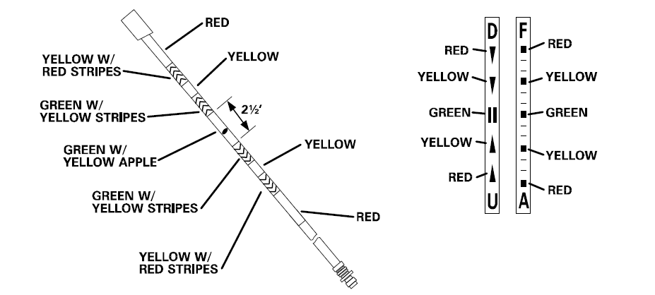

Figure 2: Boom and director lights, KC-10

The difficult part is of course to maintain the correct position:

* Make only small input corrections,
* In one axis (up/down, left/right, forward/aft) at the time, and
* Wait to see the effect of each correction.

The three points above are very important and should be done as a continuous process. By only correcting one thing at a time and waiting to see the effect, you effectively prevent pilot- induced oscillations, where you compound the behaviour you want to negate by essentially piling corrections on top of each other. This is a common mistake.

* The boom moves very suddenly as you approach for contact. Do not chase the boom, fly off the director lights.
* Mentally preface the director lights with the word “GO”. I.e. GO aft, GO down.
* Continuously cross- reference the director lights with the tanker itself: in time, you will develop a “mental image” and feel for your ideal position.
* Some pilots like to “wiggle” the throttle, that is, making continuous but very small back-and forth corrections instead of trying to match the tanker speed precisely.
* If you start seeing oscillations or struggle with anything, slide back to pre-contact, re-stabilise and try again from a stabilised position.
* Note that if you have a disconnect but is not directed back to the pre-contact, the boom operator may take some time before he is able to re-connect. All you can do is to verify that the AR/NWS light says “RDY” and maintain formation.
* If you move out of position in one direction, *both* director light columns may change. For example, if you move too far down you may get a “Go forward” light as well as “Go up”, because you’ve extended the boom as well as its angle by going down.
* The director lights will only give you up/down and forward/ aft directives, not left/ right. Use the yellow centre line marker on the belly of the tanker.
* Upon disconnecting, the aircraft may tend to go forward due to the lack of back-pressure from the boom. You can anticipate this by monitoring the fuel quantity.

* These are two techniques with different advantages and disadvantages. Find the one you’re most comfortable with:

* Using the “centre line” technique, it is easier to maintain lateral position, but a bit more difficult to establish the correct vertical position after passing the boom than the “left pass” technique, because your aircraft will be lower in order to allow the boom to pass the canopy bubble;
* Using the “left pass” technique, horizontal position is easier because you have less distance to move up after passing the boom, however, you will be off- centre and need to slide into position to the right.

BREAKAWAY

“Breakaway” is an emergency directive from the tanker to you to break away immediately to avoid a dangerous situation. Immediately reduce throttle (use speed brakes if necessary) and altitude to clear the tanker, but do not break out of the pre-contact position’s altitude block.

Aircraft in the observation positions maintains formation if it is safe to do so.

1. **RIGHT OBSERVATION**

Right observation is the mirror image of left observation:

* When disconnected, flow gently aft into the pre-contact position.
* Stabilise and close the refuelling door.
* Flow into the first open slot.
* Follow flight lead’s directive to leave the observation position, re-join formation and exit the tanker track.

Note that when you close the refuelling door, the flight control system will revert back from landing gains to normal operations. It is important to be stabilised with the stick in neutral when you do, because this will cause an increase in control input thresholds and thereby increased control surface movement. Doing so while manoeuvring will cause a slight “jump”, which can be hazardous in tight formations.

## BAS-05: **PRECISION FLIGHT** (SQ)

### SYNOPSIS

*This is a summary of the main points of precision flight. Please see the following sub-chapters for in- depth information about all aspects of precision flight, such as the instrument scan and ascending and descending flight.*

Precision flight means the ability to fly the jet within very precise flight parameters over time, in order to facilitate the “contract”, formation flight, tactical turnsand other flight activities such as landings and refuellings. This in turns enables the effective employment of the F-16 as a weapons platform as part of a flight of multiple jets in combat; BVR, WVR, air to ground and missile defense.

Most ofthe above are described in the MQT- part of the training programme, but because they all depend on precision flight, it is placed in the IQT part of the syllabus.

**Precision flight** in practice means the ability to be in absolute control over:

* Airspeed
* Attitude
* Altitude

These three quantities of airspeed, attitude, and altitudeare measured numerically, and this is where the phrase “flying by the numbers” comes from. Flying the numbers is what enables is to fly in formations, perform tactical turns and other precise flight manouvers like overhead break landings.

Whenever you are in the cockpit and your aircraft is in motion you should always know what your

intended values for these three numbers are, why you want those values, and ensure that youraircraft is configured such as to give you these exact values.

**Energy- sustaining turns** are designed to sustain the energy of the jet (and the flight) by turning at a rate that maintains the airspeed. Usually, this will be the contact airspeed of 450KCAS/M0.7.This in contrast to for example a max G turn (which will deplete your airspeed), or a turn at a set bank angle like 30° (which can be performed with different speeds across the turn).

To perform an energy- sustaining turn, enter a level turn and pull as much G as you can while maintaining the airspeed.

We do this so as to maintain the formation integrity, particularly when in a combat formation. For example, if the distance between your jet and flight lead’s is supposed to be 1.5nm, and the formation is to perform a tactical turn to a new heading and exit the turn with the same 1.5nm distance, the only way to do that effectively is if both are turning at the same speed (and therefore the same turn rate.)

The other variables of precision flight, are speed and altitude, and finally position or attitude relative to other flight members. You should be able to maintain a constant airspeed of ±5 knots of the prescribed speed, and ±25 feet of the prescribed altitude. (And of course, at the prescribed heading, but heading is easy to maintain.)

Correct position is relative to another jet, such as flight lead or a tanker. The “left observation” position on the tanker is a good example of precision flight, with speed, altitude and relative position from the tanker (the tanker’s wingtip aligned with the tanker’s cockpit window) all being within very fine parameters.

You will also be expected to fly precision flight in tactical formations with more distance between the jets. We often use “yardstick”, i.e. TACAN distance, to maintain correct distance in such cases, which will typically be the Line Abreast or Trail formations.

The best way to train precision flight on your own, is to practice aerial refuelling, as it contains all elements of precision flight. Once you’re topped off, fly some energy- sustaining turns and try flying Trail or Line Abreast of the tanker (see the Formations chapter).

### THE PILOT MINDSET

The very first thing to develop when embarking on learning to fly in an environment such as thatoffered at the 132nd Virtual Wing is that of the correct mindset. What we do is complicated,complex, and challenging. There is a huge amount of information to learn and as many skills tomaster. There is in some sense nothing causal about it. If you want to succeed and get the mostout of it, then you will need to approach it with the correct mindset.

That is a mindset that isboth ready and eager to learn. And this means that you need to be willing to put in the time forlearning and for practice. For many that’s half the fun!

The other side of the coin is that there can be no progress or improvement without the ability tosee where you are going wrong or could do with improvement. And the key is that this is true ofeveryone. The correct way to view things is to see criticism of performance not as a slight, but rather as a great way to find the opportunities for improvement. It’s completelynormal to make mistakes. Indeed, that’s a huge part of how we learn. You can even argue that ifyou are not making mistakes, then you are not learning! It pays to embrace mistakes as learningopportunities and it’s even more important not to see mistakes that others make as any different!Never be judgemental.

Remember: we are all doing this because it’s one of the most involvedand challenging forms of entertainment that modern computers connected on the internet offerus. We are all investing time to learn skills that we wouldn’t otherwise have. This is to becommended and something to take pride in. So please always keep in mind that our shared roleas members of the 132ndis to aid in each other’s mutual learning and to give positive andconstructive feedback at all stages. Remember that where any faults are pointed out to you thisis done in the spirit of supporting you and helping you reach whatever heights you yourself wantto achieve.

Embrace feedback, embrace constructive criticism, and where you give it, always tryand be as positive and respectful as possible. Together we can all achieve more than any one ofus could alone. And by being positive and supportive we can all be that person that matters, andthat makes a real and tangible difference

In the 388th we strive toward learning how to utilise ourairframe to maximum effect. We take great joy from learning to execute manoeuvres, strikes, andengage in combat in a manner consistent with the tactics and procedures used in the real-worldcombat theatre (within limits of course). This is challenging and this very challenge is one of themain sources of our shared enjoyment and sense of accomplishment.

Each flight will typically have two or four aircraft depending on the mission, and so we are always flying insupport of at least one other pilot. This means that each pilot has the responsibility to practicethe necessary skills so as not to undermine the time that the other pilots have invested to honetheir own skills. Everything we do in the 388th works whenwe all master our aircraft, and it all becomes exponentially more difficult and frustrating when evenone pilot does not. And as you will learn moving forward, precision flight is at the heart of eversingle skill required to utilise the F-16 - or indeed any other aircraft available in the DCS combatarena - and especially in an environment as rich as that offered in the 132ndVirtual Wing.

Failing to master this core skill will mean that you are actively taking away from theenjoyment and potential achievement of your fellow pilots every time you fly. Alternatively, if youdo take this skill seriously then you will become part of the proud bedrock on which the futuresuccess and potential greatness of the squadron is based. Real world pilots celebrate expertstick and rudder men with good reason indeed! Let’s do the same here in our virtual skies.

**EXAMPLE 1:**

You are flying the F-16 near enemy territory with a known SA-3 threat but noindication of that threat on the radar warning receiver. As per the briefing the pre-determinedvalues may be 400 knots indicated airspeed (KIAS) at FL140. In order to be flying by the numbersyour aircraft should be at 400 knots indicated airspeed (± 5 knots) and read 14000 (± 50ft) at alltimes.

This means that if the SA-3 system activates and launches a missile, your aircraft will haveenough energy for you to execute a defensive manoeuvre and survive the attack.

Lastly, if your wingman can’t trust you to be on speed then he/she cannot maintain the correctoverwatch position, and may fail to spot the missile launch and thus be unable to provide lifesavingvisual information that you will need to acquire and then defend against the missile.

**EXAMPLE 2:**

You are flying as a flight of two from one location to another. Your contract states cruise at350 KIAS. Your flight lead isn’t flying by the numbers. This means that you have to stay very focused on his aircraft at all times even at route spacing,and will struggle toperform even basic cockpit functions like changing radio channels or performing OPS checkswithout quickly finding yourself out of formation and potentially at imminent risk of a collision.

Inthis case your flight lead’s lack of adherence to the numbers,you have to work hard just to stay in position. More importantly it’s not fun for the wingmanand at the end of the day fun and achievement are precisely why we are doing this in the firstplace.

**EXAMPLE 3:**

Your flight has just entered a hold south of an active Close Air Support area, and youare communicating with a terminal air controller regarding ground-based targets that you arerequired to attack. The lead aircraft is anchored in a left-hand holding pattern at 12000 feet andthe wingman is following the same track at 13000 feet. Both pilots are heads-down.

Now imagine that either one of those pilots isn’t fully in control of and aware of their numbers. Thatsituation quickly becomes dangerous. Either aircraft straying into the altitude block of theother can result in a fatal collision.

Or, an aircraft experiencing a change in attitude could result inthe aircraft straying away from their known safe area and over a surface to air defence systemwhich would, of course, shoot them down.

Finally, either aircraft losing or gaining airspeed willresult in either a dangerous stall situation or an unintended holding track, both of which can resultin a fatal accident. This is a good example where using the autopilot to hold attitude and altitudewhile continuously monitoring and controlling airspeed ensures the pilot can remain on thenumbers and therefore safe.

**EXAMPLE 4:**

Your flight is at a hold awaiting a possible call to provide Close Air Support. Poor precision flight by the flight lead will lead the wingman to have to frequently change powersettings and at times maintain higher power settings in order to catch up to their lead. This willresult in higher fuel burn and - crucially - may result in the wingman no longer having enough fuelto provide critical close air support when the call comes in.

You can see that in the above examples there was always a good reason that meant that therewas no excuse not to be in complete control of the numbers and therefore of your aircraft. And so,we can clearly see that precision flight means flying by the numbers at every phase of flight. Theonly time you are not flying by the numbers is when you are on the ground and are out of thecockpit.

At every other moment your responsibility as a pilot is to make sure that thenumbers you read from your instruments match the numbers you intend. Nothing, notcommunicating, not looking for targets or threats, not coordinating with other flights or agencies,nor anything else you can imagine should ever take priority of you maintaining strict control overevery aspect of your aircraft’s motion.

### THE INSTRUMENT SCAN

The first thing that you need in order to be in control of your aircraft is to know what your numbers

are. This requires that you develop and master the skill of an habitual instrument scan. By

“habitual” I mean that you perform this as an automatic habit and at all phases of flight, even and

especially in close quarters combat like dogfighting. This is important! If you don’t make a

conscious effort to turn the instrument scan into a habit then you will find precision flight

impossible. At best you will be able to maintain precision flight with conscious effort for short

periods but then inevitably lose that control again sometimes only moments later because

whatever else you choose to do you will be guaranteed to become distracted by it. On the up

side learning this habit is the only difficult part of precision flight. Everything else is just small

stick and throttle movements.

So how do you do it? What you need to do is to consciously look at your primary flight

instruments and read your airspeed, attitude, and altitude every few seconds. Ideally you

want this to be every 4 to 5 seconds. You need to start doing this from the moment your aircraft

starts moving and continue relentlessly right up to the moment it stops again. There is never a

phase of flight where you can let this lapse. Whether you’re focussed on some area on the

ground and looking for targets, inbound on a gun-run against air-to-ground targets, or battling in a

high-G dogfight right at the edge of your aircraft’s performance envelope you must always be

flicking your eyes back to your primary flight instruments every few seconds and actively reading

and taking in the three numbers needed for precision flight:

• airspeed;

• attitude;

• altitude.

At first and like any new skill you will find this difficult. Distractions will cause you to become

fixated and the scan will just stop happening. What’s worse is that it may take some time before

you realise you’ve stopped. Also, reading the numbers may even take you the whole 5 seconds!

However if you create a few flights on your own and practice it you will quickly find that reading

the numbers becomes quick and soon you will be taking them all in with a single glance and in a

fraction of a second. Once the action becomes a habit you will even start to become unaware of

what you’re doing. The action of glancing at the instruments - reading and absorbing their currentvalues - and then returning to what you were doing becomes almost unconscious and the effect is

that of just somehow knowing them all the time. Your brain is amazing and learning to perform

repetitive actions automatically is one of our most amazing and demonstrable abilities. Just like

expert tight-rope walkers eventually stop thinking about balancing and just balance you will

eventually stop thinking about the instrument scan and just do it. But it does take a lot of

practice. Here are a few pitfalls to avoid.

First, resist having some flights where you consider the instrument scan important and others

where you don’t. Your brain simply won’t learn this habit unless you do it all the time in every

simulator that you fly. One of our unfortunate limitations is that if you teach the brain that it can

sometimes be lazy, it will default to always being lazy. It’s an energy conservation mechanism

built into our DNA. Unless we consider it vital we will subconsciously default to the option that

requires less energy. I have never personally come across an exception to this rule.

Second, don’t resist using learning aids in the beginning. Making something into a habit requires

a lot of time and energy. Not using tools to help us simply means we take longer (sometimes far

longer) to embed the habit. An example of such a learning aid is an exercise timer or timer

smartphone app. If you set an exercise time to beep every five seconds, and condition yourself to

read the instruments every five seconds no matter what (it’s a simulator so even imminent death

isn’t an excuse) then this can dramatically shorten the conditioning time needed to embed the

habit. If you resist using such tools or coming up with similarly creative solutions then you are

simply extending the time needed to embed the habit. And this may be enough to tip the scales

to you not actually developing the habit fully at all.

One thing to keep in mind while doing this is that while this one skill does require some effort over

some time, it will dramatically reduce the effort required to learn almost every other skill you will

need to succeed as a Mirage pilot by a far greater amount that you are putting in now. I

personally consider this the single most important skill related to any type of flight be it simulated

or not and in any airframe from a helicopter to every type of airplane and even auto-gyros.

### CONTROLLING THE NUMBERS

So now that we know how to know what our numbers are lets consider controlling them in a

meaningful way that also makes precision flight really easy. The key principle to understand is

that flying at a steady speed at your current altitude requires a specific amount of power.

Add any more power and you will accelerate and set any less power and you will slow down.

Because the F-16 uses a flight control computer we can ignore the vertical velocity implications

of power changes. Soreturning to our point, if you know how much power your aircraft needs to fly at a specific speedthen by setting that power your aircraft will fly at that speed all of the time that you remain straightand level and at that altitude. It won’t slow down and it won’t speed up. All we need is a way toquantify that power and a procedure to utilise the above information.

Engine output in the F16 is best referenced using the fuel flow indicator.It indicates the amount of fuel flowing through the engines in pounds per minute. The reason that it is such a useful instrument is thatsmall changes in the throttle cause relatively large changes in it’s value.If we then perform some manoeuvres thatcause the throttle position to change all we need to do in order to returnthe throttle to its original position is to move the throttle so as change thefuel flow indicator’s value back to where it was. This indicator is thus an excellenttool for throttle control

### LEVEL FLIGHT

The procedure for level precision flight is as follows:

1. Establish your desired attitude for straight and level flight.

2. Find the throttle position that maintains your desired airspeed and read and remember the fuel

flow value.

3. Before turning glance back down to remind yourself of your current fuel flow.

4. When turning or otherwise manoeuvring move the throttle to maintain airspeed during that

manoeuvre.

5. After the manoeuvre return your attitude to straight and level.

6. Once straight and level return the the throttle to it’s original position using the fuel flow

indicator.

In the above scenario you keep your flight path marker on the horizon line to maintain zero vertical

velocity and then use the throttle to get to and then maintain your airspeed. Once that fuel flow

value is found and memorised you are guaranteed to be able to maintain your speed without

variation simply by setting that fuel flow with your throttle. Dead simple. If as a result of your

regular and habitual instrument scan you notice your airspeed drifting you simply need to recheck

the fuel flow and adjust the throttle.

Be aware that the required fuel flow value for your current airspeed will change as your weight

changes. If you’ve just release a pair of MK-82’s or fired a missile you will have changed the

weight and drag characteristics of the aircraft. This will require you to find the fuel flow to hold

your intended speed again. Also, after prolonged flight your fuel levels will decrease sufficiently

lower the weight and so required a lower fuel flow. You shouldn’t really notice this as your

constant and habitual instrument scan will reveal excess airspeed buildup and result in immediate

throttle changes.

The last point to remember is that the fuel flow reading allows you to maintain your desired speed

at your current altitude. If you change altitude you will then need to determine the desired fuel

flow value for that altitude.

### GETTING EVERYTHING SETTLED

All the above is vital to controlled flight but here’s a little added detail that may prove helpful. Your

ultimate aim, when performing precision flight is moving from one settled regime to another. What

do I mean by settled? The simplest way to understand the concept is that an aircraft is settled

once all of the forces acting on it are in equilibrium. From your perspective as a pilot, the way that

you know that you are in equilibrium is if removing your hands from the controls causes no

change in the aircraft’s direction or speed, or if you prefer a more technical perspective: the forces

on your aircraft are in equilibrium if removing your hands from the controls results in no change in

the aircraft’s velocity vector. If you aircraft turns, the velocity vector is changing direction. If you

aircrafts accelerates the velocity victor is getting longer. And so on.

### ASCENDING AND DESCENDING FLIGHT

Ascending and descending flight is slightly different. In level flight you use the throttle to control

airspeed. However when ascending or descending you keep your throttle in a set position (as

briefed) and using only your attitude to control your airspeed. Here’s the procedure for ascent:

1. Set climb power

2. Pull the nose up to a position where your airspeed is constant

3. To accelerate lower the nose

4. To decelerate raise the nose

5. As altitude increases be prepared to lower the nose to maintain a constant speed

The procedure for descent is similar:

1. Set descent power

2. Push the nose down to a position where your airspeed is constant

3. To accelerate lower the nose

4. To decelerate raise the nose

5. As altitude decreases be prepared to raise the nose to maintain a constant speed

The fifth step in the above procedures is there to take into account the resulting change in

performance that the aircraft will experience as air density changes.

Once your ascent or decent is complete, return to level flight, steady your airspeed, and read the

fuel flow value needed to maintain your desired speed at your new altitude.

### TURNS

To perform a turn first decide on a bank angle. Lets assume you want to use a 30° angle of bank.

First re-read the value on your fuel flow indicator. Now roll the aircraft to that exact bank angle

and apply a small amount of back pressure to keep the flight path marker on the horizon line or

the vertical velocity indicator pointing at zero. Not allowing your altitude to change is important.

Next increase the throttle to ensure that your airspeed remains constant at your desired airspeed.

Once you have completed the turn roll your wings level and release the held back pressure.

Return your throttle to the correct cruise position such that your fuel flow is once again what it

was before commencing the turn. That’s all there is to it.

Standard bank angles for turns include 30°, 45° and 60° and it’s highly recommended that you

practice holding these angles in turns.

A few common mistakes to look out for are

• Losing or gaining airspeed during the manoeuvre. You should perform a turn at constant

airspeed.

• Losing or gaining altitude during the manoeuvre. The entire turn should sethe flight path

marker stick to the horizon line and the vertical velocity indicator pegged at zero.

### THE ENERGY SUSTAINING TURN

The energy sustaining turn is a variation of the turn that gives you the fastest possible sustained

rate of turn for your current airspeed. The key word there is “sustained”. It’s called an energy

sustaining turn precisely because it allows you to change your aircraft’s heading without losing

any of the energy stored in the form of airspeed. This phrase will become far more important

once you start air combat training but for now just be aware that airspeed and altitude are both

considered to be energy states.

To perform an energy sustaining turn you need to:

1. First apply full military power (no afterburner), then;

2. bank and pull to maintain a level turn without losing or gaining airspeed.

If you find you’re starting to descend or ascend (i.e. VVI not reading zero) then change your bank

to correct this. If you find you are starting to slow down or speed up then decrease or increase bank pressure on the stick to compensate. You really want to practice holding a constant speed

around the turn without gaining or losing altitude.

A good reason to master this turn is that it sits at the heart of tactical formation flight. Without

doing this correctly your tactical manoeuvres just won’t work. The procedure needs to be

identical too. If one pilot in a tactical formation performs an energy sustaining turn by first

banking and then applying power, while the second applies power first and then banks, then the

tactical manoeuvre will conclude with the aircraft out of position. The geometry of tactical

formations requires that both aircraft exhibit identical performance characteristics when turning.

### IN CONCLUSION

There is quite a lot to take in in this section on precision flight and quite a bit to practice. But we

will repeat our assertion that this is the single most important skill you can learn. Literally

everything else is built on top of this. Landing is just flying at the runway at the correct airspeed,

and descent angle, and angle of attack. A precision strike is just flying at the target at the correct

airspeed and attitude to ensure you are within the munition’s required release criteria. A pop-up

attack is an exercise in precision flight to ensure your aircraft is vulnerable to surface based

attacks for the shortest time possible. Dogfighting is the ultimate expression of precision flight.

Here you maintain and change your numbers intensionally at the very edge of your aircraft’s

performance envelope to gain and maintain any and every possible energy advantage you can

against a hostile opponent. As John Boyd showed a dogfight is a mathematically quantifiable

exercise in energy management and the only way to control your aircraft’s energy reserves is to be

in total control of your airspeed, attitude, and altitude.

Practice and master this singular skill while focusing on embedding the instrument scan and you

will find that every other door will open to you and that no tactic, manoeuvre, or attack will be too

difficult to learn and master quickly. Fail to master this core skill and you will have to accept that

everything else will remain difficult and often even out of reach. What’s more your lack of piloting

skill will also prevent your fellow virtual pilots from reaping the rewards of their own efforts to

master this skill. In regard to virtual aviation this is where you determine whether or not you are

able achieve the levels of skill and greatness so many aspire to but so few actually achieve.

Good luck, and may you become a true master of the stick, the rudder, and your primary flight

instruments!

## COM-01: **THE 132ND WAY OF FLYING** (IP)

The objective of COM-01 is to familiarize the pilot with the procedures of flying multiplayer within the 132nd such as communication with ATC and AWACS, and procedures around the airfield and controlled airspace.

##### Explain the difference between FL, WM, supporting and engaged.

##### Sign-up

In order to sign-up for an event, find the event on the 132nd event page, once on the page for a specific event, manuever at the bottom of the page, and click on sign up, as shown below in yellow.

You will then be listed in the pilot roster, and the event host can assign you to a flight.

If you have any restrictions or request (for example regarding timings, specific aircraft, booking of a range or airspace etc), you write that in the commschatter for the event.

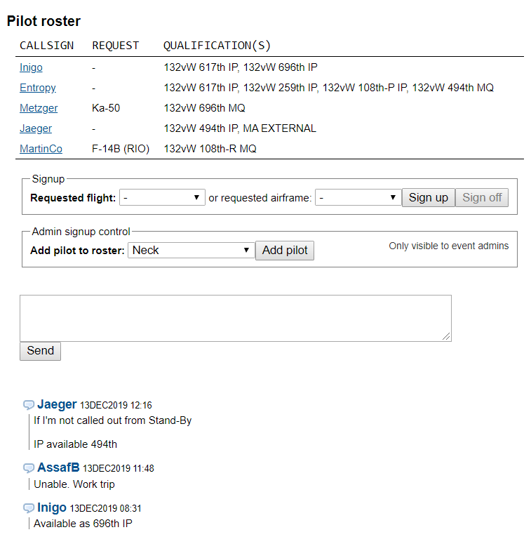

##### Event commschatter

The events commschatter is located at the bottom of the event page, as seen in the yellow circle below. Here information regarding the event in general is posted.



##### Flight Commschatter / Info

Once you are assigned to a flight, and know your tasking, you can go into the flight page, where you find information about frequencies assigned to the flight, the flights own commschatter and where to fill the flightplan for the flight. First you need to find your flight, and click on the flights mission number, as shown in yellow below.

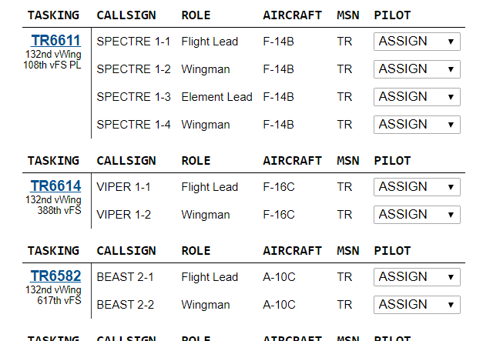

Inside the flights page, you can share information with your other flight members. The Flight Lead should and normally will publish the Mission Data Card as a link in the commschatter (Tasking chatter) in yellow below.

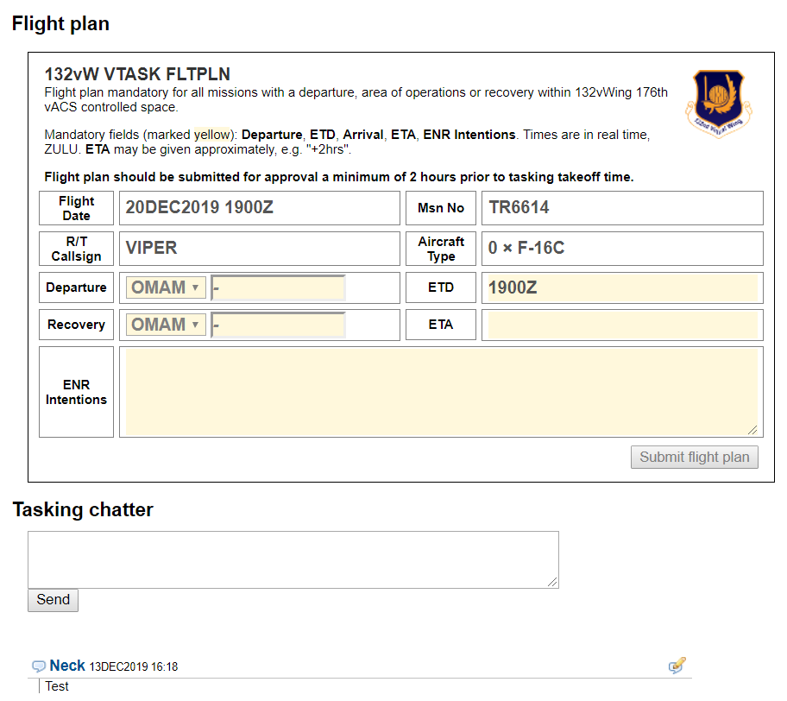

##### Flightplan

In the flight page, there is also where the Flight Lead must fill in the flightplan for the flight. This information is used by controlling agencies and for situational awareness for other flights. Fill out departure and recovery airfield. Fill out the planned departure time (ETD=Estimated Time of Departure) and the planned recovery time (ETA=Estimated Time of Arrival). Also fill in the intentions for the flight. For example, what type of departure, what is the route and taskings, and the planned recovery. In addition you can also add relevant information for controllers, such as loadouts, timings, frequencies you will be monitoring, who you will be working together with etc.

All information in the flightplan is what is a planned, and deviations might occur in flight, and that is normal and not a problem.



##### After Action Review

A good AAR and debrief is vital for getting the most out of every event – no matter the outcome!

Proper AAR's is very important both for our tactical flying and sharing lessons learned, and must be submitted by every participating member in an event.

* Objectives – A list of your flights objectives and outcome.
* Tactical – Debrief points and points about the flight you want to raise.
  + Try to answer these four questions:
    - **What happened/What did we do?** Write a short summary/story of what you did this flight. *Remember the 10%-rule* if you go into full story-mode!*
    - **What went right?** What went according to plan, or had a positive result. Did you or anyone do a good job?
    - **What went wrong?** What did not go according to plan, and why. This is perhaps the 2nd most important part of the AAR.
    - **Lessons Learned!**  The absolutely most important part of the AAR. Here you have a chance to summarize what was learned from the above points.
* Design – Technical feedback on the mission, bugs etc. *(OPTIONAL)*.
* Admin – Feedback to the event host. Issues etc. *(OPTIONAL)*.

##### Communication the 132nd Way

Radio communication is vital to ensure coordination and mission success, and Radio communication will have one of three purposes:

* Ask for clearance(s)
* Give instructions
* Receive Instructions

**Note:**

VHF/UHF Radios are one-way communications only. We want efficient delivery of information by using as few words, in the shortest time possible in order to get our message across while freeing up the radios as much as possible.

During a flight, you (or FL) will talk to THREE or FOUR agencies:

* *GROUND (GND) (Not always used)*
* TOWER (TWR)
* CONTROL (CTRL)
* AWACS (DARKSTAR/MAGIC/CRYSTAL/OVERLORD)

And request THREE clearances:

* GND/TWR: Taxi Clearance
* TWR: Departure Clearance
* TWR: Landing Clearance

Controlling agencies

The purpose of each agency is to be the controlling authority of a geographical area and its airspace.

The agencies provide services and coordination for the flights within their airspace.

The illustration below is taken from the controllers view and shows the four agencies and their geographical responsibilities for Tbilisi-Lochini Airport (UGTB) as an example. GND controls activity on the airfield, expect the runway. TWR controls the runway and the immediate airspace surrounding the airfield. CNTRL controls a wider area, what is also known as a Terminal Manuver Area (TMA) surrounding the airfield or cluster of airfields. CNTR’s role is to manage the traffic flow in and out of the airfield in the most efficient way.

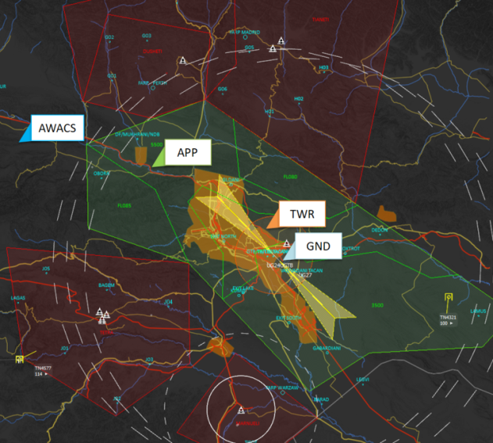

FLIGHT INTERNAL COMMUNICATIONS

All communications internal to the flight is transmitted on the internal frequency. This can be either the UHF or VHF radio, and it will change for the various phases of the flight. On the internal frequency, we use the last number in the flight as our identifier, but when communicating with externals outside the flight we use the full callsign (Example: “1” on internal, “JEDI 8-1” for external).

Make it a habbit to acknowledge all calls from FL. A simple “2” is enough, that way lead know that you have recived the message. If you do not respond with a “2”, then FL will not know if you received the message or not.

Once the flight is airborne it becomes vital that each member knows where the others are. This is done by using specific words, called Brevity codes

* **Visual** is called when you have another aircraft in sight, e.g.;
  + *«2, visual on Lead»*
  + *«2, visual 1 & 3»*
  + *«2, visual 1, blind 3»*
  + To assist in overall Situational Awareness the visual call should add the location where his other flight will have to look in order to see you, e.g. «2 visual on Lead, your 5 o’clock low». FL now knows he should check his 5 o’clock low to get you visual.
* **Blind** is called when you are not visual on another aircraft and you altitude and heading is added to the announcement;
  + *«2, blind on Lead, 4100ft heading 020»*
  + *«2, blind on Lead, FL085 heading 190»*
  + In case of a Blind call the other aircraft should reply immediately with status. If FL is Visual then de-confliction is still maintained. If not then you must recover to level or climbing flight immediately in order ensure de-confliction. If both flights are blind, FL will provide a deconfliction directive to ensure that the flight not crash into eachother. Remember that it is your responsibility as a wingman to not fly into leads aircraft.

For navigation there also some specific Brevity used;

* **Check left/right** (heading), Turn in the direction given and maintain the new heading, e.g.;
  + *«2, check left 90», meaning turn left 90 degree*
  + *«2, check right heading 180», meaning turn right until heading 180*
* **Established** means that you are now currently at the specified altitude, heading, location etc.;
  + *«2, established heading 020»*
* **Saddled** means you are in formation, where FL wanted you to be
  + «2, saddled left»
* **Pad-locked** means you are keeping your eyes on FL, mirroring his move and keeping formation. FL is now free to maneuver without calling out position changes.
  + *«2, pad-locked»*
  + **If you are pad-locked, and FL requests you to do a task you deem unable to do without taking your eyes off of him – you MUST report. DO NOT TAKE YOUR EYES OF LEAD!**
  + *«2, unable - pad-locked»*
  + *«1 copies – Kick out»*
* **Kick Out** is an instruction to put some space between you and FL
  + *«Kick out 1 nautical mile, tactical spread»*
  + *«2»*

**EXAMPLE MISSION**

For this example our flights call-sign will be **JEDI8** and we will act as a flight of two F-16Cs :

JEDI8-1 (Flight-Lead) and JEDI8-2 (Wingman)

In the example below you should observe certain patterns:

* Communication starts with
  + *«[Station Call-sign], [Caller Call-sign] <message>»*
* The receiving station replies with
  + *«[Caller], [Station] <message, clearance or instructions>»*
* The conversation (usually) ends with the caller acknowledging or reading back what was transmitted
  + *«[Station] - turn left heading 130 [Caller]» or the caller just replies with his call-sign – equivalent to saying COPY, or AFFIRM or WILCO depending on the context*

**Check-in internal frequency**

* Check-in with Flight-Lead (FL) on UHF (COM1) after powering the aircraft:
  + *WM: “ 1, this is 2, checking in internal Uniform”*
  + *FL: ”1, loud and clear”*
* FL might perform a full flight check:
  + *“JEDI8, check-in uniform”*
  + *“2”*

**ATIS**

* Check-in on ATIS frequency to get latest weather and active runway. This is a automated broadcast, so you do not need to say anything, just listen to the messagebeeing transmitted.

**Alpha check / ready to start engines**

* Once you have completed the startup and are ready to do an alpha check, and start your engines you report to FL on internal frequency:
* **WM:***”2, ready alpha check”*
* **FL:***”1, copy, Waypoint 1, 250 for 35”*
* **WM:***”2” or ”2, error”* (error if you do not gethe same as FL, check and after the alpha check)
* **FL:***”Waypoint 2, 300 for 70”*
* **WM:***”2”*
* **FL:** ”Alpha check complete, cleared to start engine”
* ***WM:*** ”2”

**TAXI Clearance**

After start-up is complete, check-in with Flight-Lead (FL):

* **WM:***“2, ready to taxi”*
* **FL:***“1”*

FL will ask ground (GND) for taxi clearance to the currently active runway:

* **FL:***“Lochini Ground, JEDI8-1, with information ALPHA, Request taxi to active runway.”*
* **GND:***“JEDI8-1, Ground. Taxi to active Runway 31L is approved. Taxi via CHARLIE, APRON 4 on to ECHO – crossing NOVEMBER, continue on ECHO – Hold short 31L”*
* **FL:***“Lochini Ground, JEDI8-1. Taxi to 31L via CHARLIE, APRON 4 on to ECHO – crossing NOVEMBER and continuing on ECHO. Hold short of active”*

FL will call his flight to start taxiing:

* **FL:***“1 is rolling”*
* **WM:***“2”*

Holding short of the activerunway , FL will call GND again:

* **FL:***“Lochini Ground, JEDI8-1 holding short 31L”*
* **GND:***“JEDI8-1, Ground. Contact Tower on 138.2”*
* **FL:***“Contact TOWER on 138.2, JEDI8-1”*

FL has been instructed to contact another agency, requiring a frequency change. As described earlier, all frequency changes follow a similar pattern. Starting with FL giving instructions on internal, here, Uniform, to his flight:

* **FL:***“Flight push preset3, victor”*
* **WM:***“2”*

**DEPARTURE CLEARANCE TWR**

After switching to TOWER frequency, FL will continue the procedure and ask his flight to check in on Victor before continuing his communication with TOWER

**FL:** *“JEDI, check-in Victor”*

**WM:***“8-2”*

**FL:***“Lochini Tower, JEDI8-1. Holding short 31L”*

**TWR:***“JEDI8-1, line up runway 31L, call ready to receive departure clearance”*

**FL:***“Lining up, JEDI8-1”*

FL will communicate any instructions to his flight on line-up on FRONT at this point

**FL:***“Lochini Tower, JEDI8-1. Lined up and ready to receive departure clearance”*

**TWR:***“JEDI8-1, Tower. After departure, continue runway heading and report passing 5000ft”*

**FL:***“Tower, JEDI8-1. Continue runway heading, report passing 5000”*

**TWR:***“JEDI8-1, report ready for* ***departure****”*

FL will check with his wingmen that his flight is ready for departure

**FL:***“Tower, JEDI8-1 ready for departure”*

**TWR:***“JEDI8-1, Lochini Tower. Wind 150 at 4 knots. Runway 31L cleared for* ***take-off”***

**FL:***“Cleared for take-off, JEDI8-1”*

At this point FL will give any last remarks to his flight before taking off. At 5000ft he will report to TOWER as requested above:

**FL:***“Tower, JEDI8-1 passing 5000ft”*

**TWR:***“JEDI8-1, contact APPROACH on 127.1”*

**FL:***“Contact APPROACH on 127.2, JEDI8-1”*

**CHECK-IN CONTROL / AWACS**

After switching to CONTROL frequency, FL will again perform check-in on AFT as before

FL will then check in with CONTROL:

**FL:** ”JEDI, check Victor”

**WM:** ”2”

**FL:“***Tbilisi Approach, JEDI8-1 – Passing 5000ft and climbing, heading 301”*

**CNTRL:***“JEDI8-1, Lochini Control. Positive radar contact. Climb and maintain FL240, turn left inbound Mukhrani”*

**FL:***“Climb and maintain FL240, left turn inbound MUKHRANI– JEDI8-1”*

When the flight is about to cross out of the TMA, approach will push the flight onto the next controlling agency: AWACS. AWACS is controlled by a Senior Weapons Director (SD) with call sign DARKSTAR and is the highest controlling agency within the 132nd. Normally ATC operations takes place in the Victor radio, while AWACS communications take place on the Uniform radio.

* **CNTRL:***“JEDI8-1, Approach. Contact DARKSTAR on 237.0”*
* **FL:“***Contacting DARKSTAR on 237.0, JEDI8-1”*

FL and the flight will thenswitch internal radio to victor, to use uniform for AWACS, before checking in with DARKSTAR

* **FL (on Uniform):** ”JEDI, push Victor preset 1”
* **WM (on Uniform):** ”2”
* **FL: (On Victor):** ”JEDI, check Victor”
* **WM (On Victor):** ”2”
* **FL (On Victor):** ”JEDI, push Uniform, preset 4”
* **WM (On Victor):** ”2)
* **FL (On Uniform):** ”JEDI, check Uniform”
* **WM (On Uniform):** ”2”
* **FL:***“DARKSTAR , JEDI8-1 with you at FL240 passing MUKHRANI.”*

DARKSTAR will at this point perform an authentication using the AET-100 table.

* **AWACS:***“JEDI8-1, DARKSTAR . Authenticate ALPHA DELTA TANGO****”***
* **FL:***“JEDI8-1 authenticates ZULU. Authenticate ALPHA KILO INDIA”*
* **AWACS:***“DARKSTAR authenticates HOTEL. JEDI8-1 send check-in”*
* **FL:***“DARKSTAR, JEDI8 is two times F-16s checking in as fragged”*
* **AWACS:***“JEDI8-1, DARKSTAR. Copy, continue as fragged”*
* **FL:***“JEDI8-1”*

Your flight at this point, JEDI have now completed a departure from the TMA and is ready to continue on its training as fragged (as ordered/planned/stated in flightplan).  
  
DARKSTAR might choose to push you to another Weapons Director, like MAGIC or CRYSTAL. However, combat communications and AWACS check-inis beyond the scope of this lesson.

**WHAT HAVE WE LEARNED SO FAR?**

* How to prepare ourselves and the aircraft in order to use radio efficiently
* The necessary clearances needed and what agencies are able to provide them
* There is a pattern and a reputability to the “language” spoken on the radios. Recognize this pattern, and the rest will come easily.
  + During your flights, think about the next step. What clearances will you need next? Go through the conversation mentally.
  + Listen in on what your Flight Lead is saying on both radios. What will he ask for next?
  + Should you end up as a singleton – Don’t panic! Remember the clearances and their sequence. On returning to base, the procedure is almost the exact opposite.
  + Remember that instructions or messages are of no use if it is not received or misunderstood. There is no shame in asking the agency to repeat the message. To the best of your ability - make sure you received everything correctly.
* Think about what you are going to say / answer BEFORE you press the PTT button.   
  We don’t want to be blocking the whole frequency while thinking.

RETURNING TO BASE

The procedure for getting home can be broken into the following steps:

* + Checking out with AWACS
  + Checking in with CONTROL and continue through the airspace
  + Check in with TOWER to receive final vectors and Clearance to Land
  + Check in with GROUND to receive taxiing instructions back to parking

It is more or less the exact opposite of what we do on departure!

Depending on the situation and metrological conditions, agencies will give you instructions on where to fly and what altitudes to keep in order to get you back home safely. There is too much variation to what could be transmitted in order to give examples for everything in this presentation. However, these instructions are fairly straight forward and self-explanatory.

There are a few terms that you might encounter on your way back:

* **Straight-in Approach:**  
  This is the normal airliner type landing where you come straight on to the runway from 8-10nm on a nice glide-slope
* **Overhead Break:**This is the preferred way of recovering military aircraft. Fighters come in fast, on runway heading overflying the runway, at approximately 1500ft AGL at 350kt and will perform a medium to high-G 180° turn down wind for final - bleeding off speed in the process
* **Join [left-hand] circuit [or pattern] – you are number 2 for landing:**There are multiple flights waiting to land. ATC is putting all flights into a rectangular pattern on the cold side of the runway and is instructing your flight to join. He is also instructing that your flight is number two in line for landing.
* **Pattern Altitude:**The altitude flights entering into the pattern is expected to keep

**NOTE:** Further explanations can be found in the TTP-5 ATC and Airbase Operations, Appendix A

The F-16 is a fast jet - Check in with CONTROL early!

Check in with CONTROL while still a few minutes out of the TMA. He will be able to provide better service, and you reduce the risk of being put into a holding pattern – waiting to descend. We want to get back on ground and get ready for the next one!

**CHECKING OUT WITH AWACS**

The flight has finished its mission, and FL will state his intentions to AWACS:

* **FL:***“DARKSTAR, JEDI8 has finished our business, JOKER and RTB at this time”*
* **AWACS:***“JEDI8, DARKSTAR copies all. FL220 for transit, inbound MUKHRANI”*
* **FL:***“FL220, JEDI8”*

A few minutes before reaching the TMA, FL will check out with AWACS:

* **FL:***“DARKSTAR, JEDI8 – Just outside the TMA, leaving your frequency”*
* **AWACS:***“JEDI8, DARKSTAR copies. APPROACH frequency is 127.2 So long!”*
* **FL (Victor):** *“JEDI, push Uniform, preset 1” (Back to internal on Uniform)*
* **WM (Victor):** *“2”*
* **FL (Uniform):** *“JEDI, check Uniform”*
* **WM (Uniform):** *“2”*
* **FL (Uniform):** *“JEDI, push Victor, preset 4”*
* **WM (Uniform):** *”2”*
* **FL (Victor):***”JEDI, check Victor”*
* **WM (Victor):***”2”*

**CHECKING IN WITH CONTROL**

After having checked out with AWACS, FL will check in with CONTROL to let him know his intentions and give him an idea of where the flight is in relation to his airspace.

We can expect CONTROL to give us vectors and altitude necessary to position us towards the runway or pattern before handing us off.

* **FL:***“LOCHINI CONTROL, JEDI8 with you from the WEST – FL220, inbound for full stop landing”*
* **CONTROL:***“JEDI8, LOCHINI CONTROL. Identified, decent FL060 and turn right inbound Lochini. Report runway in sight”*
* **FL:***“Wilco, FL060 inbound Lochini. JEDI8”*

As we continue towards the airfield, we do as instructed

* **FL:***“CONTROL, JEDI8 – FL060, runway in sight”*
* **CNTRL:***“Copy that JEDI8, contact TOWER on 138.2. So long”*
* **FL:***“Tower on 138.2, JEDI8”*

Optionally APPROACH might also contact FL to initiate the push to TOWER

* **CNTRL***: “JEDI8, contact TOWER – frequency 138.2”*
* **FL:***“Tower 138.8, JEDI8”*

*CHECKING IN WITH TOWER – OVERHEAD BREAK*

The flight is now on the home stretch. Flight has been pushed to Tower – and again FL will check in, stating intensions and giving a rough position

* **FL:***“Tower, JEDI8 - FL060 just short of Lochini inbound for full stop landing via* ***overhead break****”*
* **TWR:***“JEDI8, Tower - Copy. Turn left 320 for runway 31 Left. Cleared overhead break. Report downwind.”*
* **FL:***“Left 320 for 31 Left, cleared overhead break. Wilco, JEDI8”*

Tower gave instructions to report downwind. The flight will perform the overhead break, and then report in. In the following example, the flight is landing as singletons – not in formation. This means each member will have to report downwind and final on his own.

* **FL:***“TOWER,* ***JEDI8-1*** *downwind”*
* **TWR:***“JEDI8-1, Copy – Report final with gears down and locked”*
* **FL:***“JEDI8-1”*

If all went well, JEDI8-2 will be out of the break about 5 seconds after 8-1

* **WM:***“TOWER,* ***JEDI8-2*** *down wind”*
* **TWR:***“JEDI8-2, Copy – Report final with gears down and locked”*
* **WM:***“JEDI8-2”*

While FL performs his landing, JEDI8-2 will now configure the aircraft for landing, turn in on final and report in

* **WM:***“TOWER, JEDI8-2 on final. Gears down and locked”*
* **TWR:***“JEDI8-2, wind 150 degrees at 10 knots. Runway 31 Left cleared to land*

Once landed, JEDI8-2 will vacate the runway and hold short on the taxiway

* **WM:***“TOWER, JEDI8-2 runway vacated”*
* **TWR***: “JEDI8-2, TOWER. Copy – contact ground on 138.1. Good night”*
* **WM:***“Ground 138.1, JEDI8-2 – Good night*

CHECKING IN WITH GROUND

The flight is now on the ground, holding at a taxiway just off of the runway. FL will contact ground to request taxi clearance. If you landed as singleton, each flight will have to request their own clearance

* **FL:***«GROUND, JEDI8-1 holding at Bravo, runway vacated»*
* **GND:***«JEDI8-1, GROUND – Taxi to parking APRON 1 via BRAVO and CHARLIE»*
* **FL:***«APRON 1 via BRAVO and CHARLIE, JEDI8-1»*

As the flight arrives at APRON 1, FL will notify GROUND

* **FL:***«GROUND, JEDI8-1 parked APRON 1 and shutting down. So long»*
* **GND:***«GROUND copies. Have a good day»*

##### Altitude and flight levels

**QNH (Naval Height)**

* “Height” - Based on setting a locally provided altimeter setting which is determined by adjusting an altimeter on the ground until it reads the station's correct elevation above the sea level reference datum. As the aircraft altimeter is set for QNH before taxi the altimeter will show runway height above sea level, i.e. app. 1560ft for Lochini.
* When altimeter is set for QNH the vertical position of the aircraft is referred to as altitudes in feet.

**SPS/QNE (En Route)**

* “En Route” - Based on setting 29.92 inch Mercury or 1013.2 hPa, gives height above a theoretical datum which is not adjusted for atmospheric conditions.
* In order to obtain the same reference between flight coming from different airports the 132nd Virtual Wing uses Standard Pressure Setting/QNE when en route at higher altitudes.
* When altimeter is set for SPS/QNE the vertical position of the aircraft is referred to atflight level in 100 feet, e.g. altimeter shows 12000ft which translate to FL120.

**QFE (Field Elevation)**

* “Field Elevation” - Based on setting a locally provided altimeter setting which is determined by adjusting an altimeter on the ground until it reads zero. QFE allows us to read height above the runway, i.e. while on the runway altimeter will show 0 feet.
* When altimeter is set for QFE the vertical position of the aircraft is referred to as height in feet.

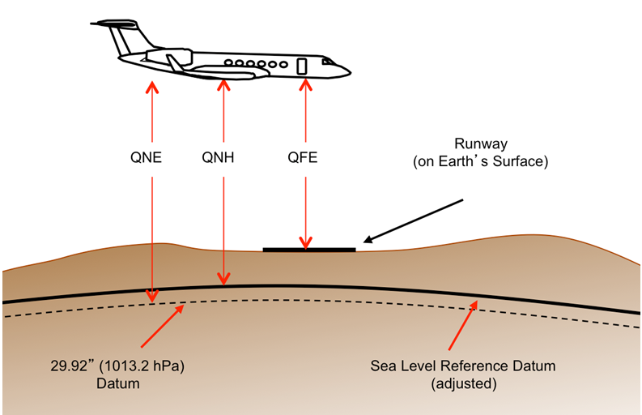

##### Authentication

AET-100

TAT-100

RAMROD

### DEPARTURE PROCEDURES

#### **TAXI**

Taxi is started either by a voice order from Lead or when he switches on the landing light. For a landing light taxi start, all pilots in a Flight must be visual and after entering the cockpit.

Avoid using a quick burst of afterburner to get yourself moving and always remember to carry out the taxi checks. As a minimum you should check: NWS is enabled, Flight Controls have full and free movement and your brakes before you get up any real speed, better to find you have a brake failure now than run into the back of another aircraft during taxi. Aircraft taxi in turn, keeping a safe slow speed (no more than 20 knots).

A throttle setting of 77%-82% is quite adequate and even that may need to be backed off once rolling. Keep a good distance behind the aircraft in front.

Spacing may however be reduced when holding short of, or entering the runway. Flighleads should follow ATC instructions whenever possible, but it is the responsibility of all pilots to avoid a collision using the see and avoid principle. While on the ground you are required to give way to aircraft to your right, any aircraft on an active runway and any aircraft on final. Remember, AI aircraft may not comply with this SOP so be vigilant at all times and under no circumstances should you enter an active runway unless certain there is no traffic departing or landing. All aircraft must use the active runway(s), as declared by ATC/ATIS.

#### **TRAIL TAXI**

In trail taxi all aircraft taxi with their nose gear on the centre line and keep adequate spacing between aircraft to ensure there is no risk of a collision. For a guide use a minimum of 50 meters or 150ft, which at 10-15 knots is 5-7 seconds behind the aircraft in front. You can also judge the correct distance by ensuring the wingspan of the aircraft in front is approximately half the width of the HUD.

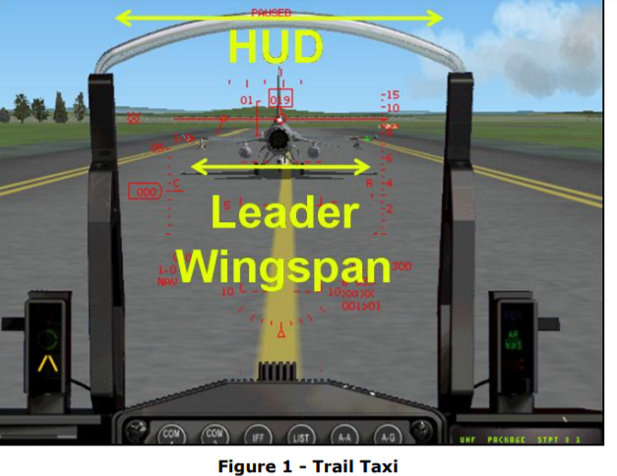

#### **STAGGER TAXI**

In a stagger taxi, aircraft put their nosewheel in the centre of either the left or right lane of the taxiway. This allows aircraft to taxi at a closer distance to the aircraft in front, useful when visibility is limited, timings are tight or the airbase is very busy.

Stagger taxi is only to be used when the taxiway is wide enough to ensure sufficient wingtip clearance from obstacles and all aircraft must ensure they remain in their own lane to avoid any risk of collision. For a guide keep a gap of 30 meters or 100ft. You can also judge the correct distance by ensuring the wingspan of the aircraft in front is approximately 3/4 the width of the HUD. The Flighlead should taxi on the side of taxiway for the direction of turn (i.e. right turn - right side or left turn - left side). Other aircraft in the Flight stagger on opposite sides (e.g. #1 right #2 left #3 right #4 left).

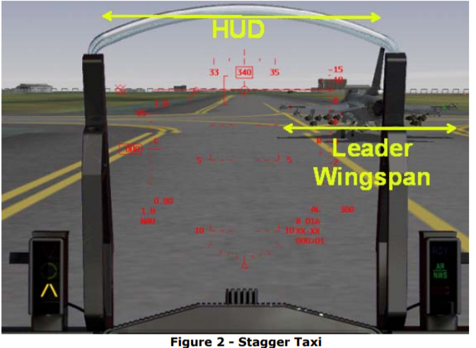

#### **LINE UP**

SOP line-ups are shown below. #1 position themselves on the same side of the runway as they occupied on the taxiway, leaving enough room behind them for the Flight to line up. However, if there is a strong wind from one side #1 will use the lane furthest from the wind direction for two reasons, most importantly wake turbulence, but also to avoid #2 loosing engine performance from #1’s jet efflux temp. For an Element or Echelon line-up #2 will be staggered with their head in-line with #1’s main gear. #2 must maintain wingtip clearance with lead. If in a three/four echelon line-up, #3 and #4 should align helmets of the preceding flight members. If in a three/four-in-the-slot line-up, #2 should line-up in Echelon but with sufficient wingtip spacing to allow #3 and #4 to establish position without wingtips overlapping. #3 and #4 should line up in Echelon with four lining-up where he can see his element mate’s cockpit in front of two's vertical stabilizer.

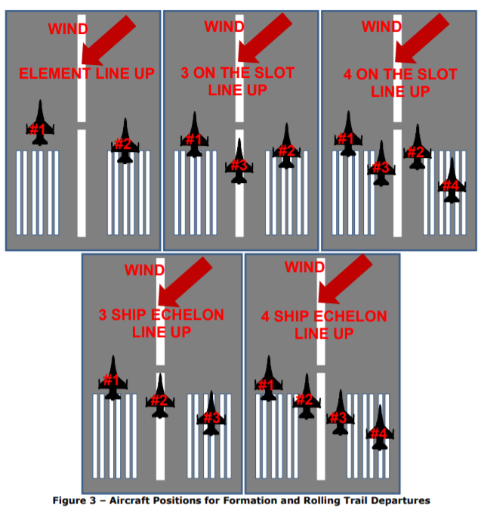

#### **FORMATION TAKEOFF**

The following apply to formation takeoffs:

It is a primary responsibility for the flightlead to ensure the formation take-off is safe. The main danger is the risk of a collision therefore formation takeoffs are restricted to Elements unless there is sufficient runway width to maintain wingtip separation between all aircraft throughout the take-off roll. Remember as a flightlead you need to think about what might happen in the event of an aborted take-off.

The formation take-off procedure is:

* 1. On Lead’s command *“Run-em up”* aircraft increase the RPM to 80%, check engine parameter are within limits and check over aircraft to their left or right for any visible problems or incorrect configuration. Once these checks are complete, aircraft check in with *“(Callsign) green”* in Flight order.
  2. On Lead’s mark *(“Brakes, brakes, go”)*, aircraft go to max-MIL or max-AB as briefed by flightlead and release the brakes. Once flightlead reaches max-MIL or max-AB they should decrease the thrust a little (not below 40% nozzle open) to give wingmen a small power advantage that will enable them to remain in position.
  3. Wingmen stabilise with wingtip clearance. If they get the jump on lead, they should reduce power slightly to maintain position. The best technique is to concentrate on flying formation from brake release, then match lead's rotation rate.
  4. NWS should be disengaged before 70 KIAS with rotate normally between 150- 180 KIAS as pre-briefed by Lead. Gear retraction must occur before 300 KIAS to prevent damage.
  5. Last aircraft in the flight will make the call *”(Callsign) Airborne, gear up and visual”*
  6. If a wingman overtakes the flightlead, they will be directed to assume the lead while continuing the takeoff. If any aircraft must abort, the other members should continue the takeoff. In either case, directional control (staying in the correct position on the runway) is essential to prevent collision.
  7. Normal take-off separation between Elements is a minimum of 10 seconds. When join-up is to be accomplished above the cloud or when carrying live air-to-surface ordnance, take-off interval will be increased to a minimum of 20 seconds.

#### **TRAIL DEPARTURE**

A trail departure is normally used to get a flight of two or more airborne when conditions won't permit a formation takeoff or rejoin out of traffic. Wet runways, crosswind limits, weapons loads, configuration differences, and low ceilings or poor visibility are normally deciding factors. There are two types of trail departure. The standard trail departure and the rolling trail departure:

STANDARD TRAIL DEPARTURE

The Standard Trail Departure

1. Line up ensuring wingtip clearance between all aircraft then pilots check in with *“# (position in flight) ready”.*
2. #1 release the brakes and sets max-MIL or max-AB for departure. #2 follows at the briefed interval. They are followed by #3 then #4 with the same interval.
3. NWS should be disengaged before 70 KIAS with rotate normally between 150- 180 KIAS as pre-briefed by flightlead. Gear retraction must occur before 300 KIAS to prevent damage.
4. Last aircraft in the flight will make the call *” # (position in flight) Airborne, gear up and visual”*

ROLLING TRAIL DEPARTURE (Rolling takeoff)

A rolling takeoff means that the flight does not hold short or line-up on the runway. The takeoff is a immediate extension of the taxy adjusted to takeoff spaceing by flightmembers. Requested and approved by either by ATC or Flight-lead to expedite the takeoff.

A rolling takeoff can also be performed on narrow (or short) runways where a line-up can be a hindrance.

1. Flight lead must ensure that line-up checks has been performed by the flight and take-off clearance has been received from ATC.
2. Last aircraft in the flight will make the call *” # (position in flight) Airborne, gear up and visual”*

# MISSION QUALIFICATION TRAINING(MQT)

## TAC-01: **FORMATION AND TURNS** (IP)

The objective of TAC-01 is to familiarize the pilot with the formations and turns used in the 388th Peregrines. Formations and turns are used tactically, and achieves several important things for the flight, such as mutual support, visual coverage, massing of firepower and a common point of reference. Before the actual turns and formations are discussed however, there are some basics that should be explained. This chapter will be structured as follows:

* Fundamentals
* Cockpit references
* The contract
* Formations
* Turns

### SOME FUNDAMENTALS

Maintaining **mutual support** is a key objective of formations and turns. By “mutual support”, we mean the ability of each flight member to support the other by being in formation, enabling visual lookout coverage of the wingman’s six o’clock and blind spots (underneath and behind the aircraft) and the ability to respond to threats. This can be for example calling out incoming ground fire on the radio, or engaging an enemy fighter with weapons. I.e. good mutual support maximizes the entire flight’s offensive posture, situational awareness and thereby its ability to achieve its mission objectives by providing:

* Positional awareness of flight members and other units around the formation.
* Early detection and positional awareness of threats.
* Support decision making, particularly whether to attack or disengage.

Mutual support is part of the “contract” discussed later.

**Visual lookout** is a critical part of mutual support, and is an absolute priority for all flight members. The formations are designed to provide the best possible visual coverage, and to deny an enemy an unseen entry into the formation. This of course presupposes that someone is actually looking. For this reason, we use visual scan sectors, very much like how lead and wingman have different radar scan responsibilities: see the contracts- section below.

The wingman or supporting fighter have a particular responsibility for maintaining a constant visual scan around the formation, because the flight lead or engaged fighter is often “heads down” working with a sensor. Although “heads down” should be called out, it is very often the case that the lead pilot is preoccupied with sensors to a greater degree than the wingman. Have this in mind whenever you fly in a supporting position. (From experience, it is the wingman who first spots other aircraft.)

Flying the F-16 in a complex environment requires continuous attention to numerous tasks and responsibilities. However, *you can only ever do one thing at the time*. Get into the habit of mentally assigning yourself single tasks at the time, as the time and situation allows. For example:

* High altitude, “low workload”: *Full visual scan🡪 Flight instruments🡪 Radar🡪HIS🡪repeat.*
* Low level, “high workload”: *Limited visual scan🡪 Flight instruments🡪repeat.*

### COCKPIT REFERENCES

The following are useful references when flying formations, or for quickly calling out references to any observation:

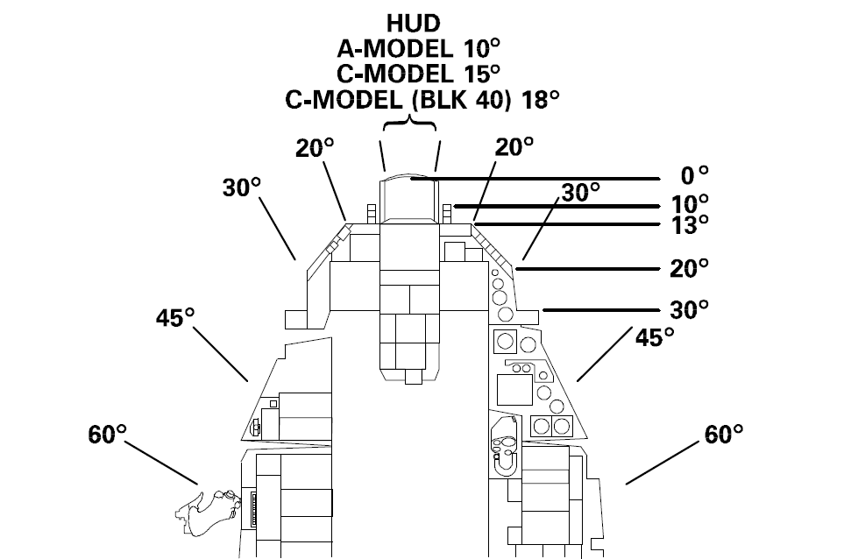

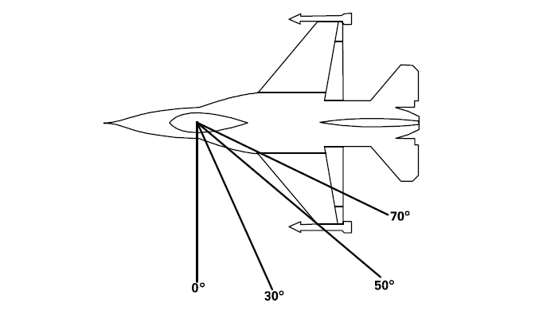

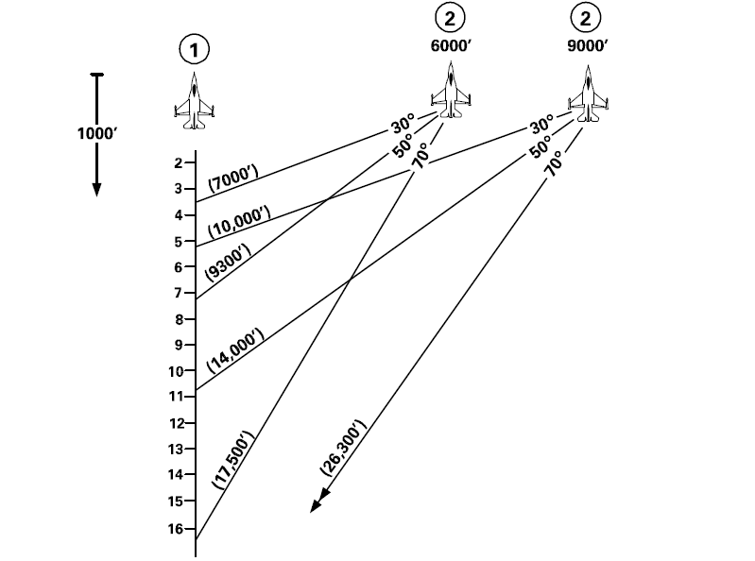

### FORMATION RESPONSIBILITIES

* **FLIGHT LEAD:** Primary decision maker, flight- external communications, navigation and radar lookout, and engaged fighter if practical. Mutual support for wingman.
* **WINGMAN:** Maintain formation and deconfliction, visual lookout and mutual support for Flight Lead. Navigation, radar and other situational awareness as other responsibilities allow.
* **ELEMENT LEAD:** Support Flight Lead. Secondary decision maker, flight- external communications, navigation and radar lookout, and secondary engaged fighter if practical. Mutual support for wingman and the rest of the flight.
* **ELEMENT WINGMAN:** Maintain formation and deconfliction, visual lookout and mutual support for Element Lead.Navigation, radar and other situational awareness as other responsibilities allow.

### VISUAL LOOKOUT

The visual lookout pattern applies to all flight members as their responsibilities allow, and is designed to monitor the aerospace around the aircraft and the flight in prioritised order. (This means that if you for example are down at low level and manoeuvring, and padlocked on the flight lead, you may only be able to scan sector 1 and occasionally 2.)

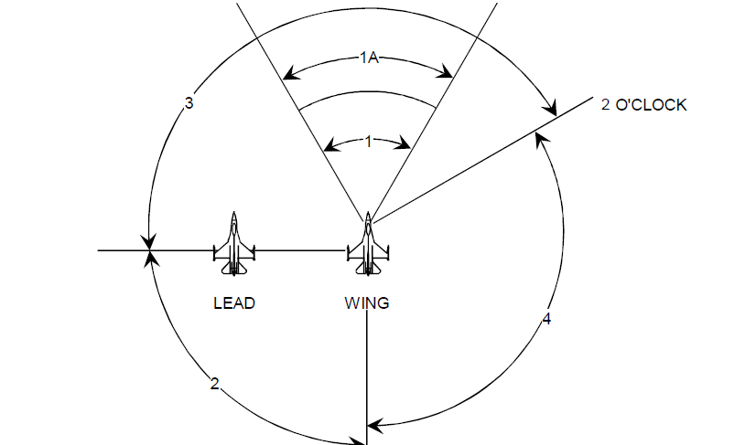

* **SECTOR 1:** This sector is called NEAR ROCKS, and is anything that may constitute an immediate threat.
* **SECTOR 1A:** This sector is called FAR ROCKS, and is anything that would affect future manoeuvring.
* **SECTOR 2:** This sector is the six o’clock position. Notice in the image above how the wingman scans the flight lead’s six, and although not indicated, flight lead’s sector 2 is the wingman’s six.

Sectors 1 and 2 make up the basic lookout cross-check, which should be checked on each lookout cycle:

***“NEAR ROCKS, FAR ROCKS, CHECK SIX.”***

* **SECTOR 3:** This sector is *inside* the flight, and *ahead* of the flight’s 3/9 line.
* **SECTOR 4:**This sector is *outside* the flight and *aheadand behind* the 3/9 line. Sector 4 completes the full 360 degree of the visual lookout.

### THE CONTRACT

The “contract” is a set of pre-defined parameters and responsibilities we use to standardise and “automate” certain tasks in the flight, such as standard departure line-ups and cruise speeds. Key parts of the current contract are always provided in the 388th Kneeboard Pack/ In-flight Guide document.

The contract consists of the following elements:

1. **Flight Parameters during different stages of flight and turns**

Specified in the In-flight Guide.

1. **Formation Responsibilities**

See above.

1. **Visual Lookout**

See above.

1. **Radar Scan**

Specified in the In-flight Guide.

I.e., by having a contract, we do not need to pre-brief things like re-join- and cruise speeds, radar scan responsibilities, landing patterns or that all tactical turns are conducted as energy sustaining turns.

If nothing else is briefed, follow the contract.

Now, with the basics covered, it is time for formations and turns:

### TACTICAL FORMATIONS

Varying factors of the tactical arena (weather, visibility, background, terrain, threat, etc.) will

determine the position and responsibilities for the individual flight members. Central to all maneuvering must be a capability to communicate intent, role, and threat information. Definitions of pilot responsibilities and emphasis on air discipline will help ensure success in a restricted communications environment. The formations described in this chapter are applicable for both air-to-air and air-to-surface operations. The guidelines given have proven to be the most universally applicable. As the tactical situation changes, the numbers given here may change. Remember, flying a given formation is not an end in itself; it facilitates proper task prioritization, lookout, and offensive/defensive considerations. If you cannot perform your responsibility in a formation listed, get into one which does permit you to carry out your formation responsibilities. The flight briefing should cover, as much as possible, any changes that may be necessary.

#### **FORMATION SELECTION**

The basic combat formation employed by tactical fighters is the four-ship flight. The two-ship element is the basic fighting unit. The wingman's main duty is to fly formation on his leader and to support him at all times. He is to clear the area and perform his portion of the briefed mission. A four-ship flight consists of two elements directed by the four-ship flight lead, increasing the mutual support of all.

Considering the variety of air and surface threats, terrain, weather, target arrays, and mission objectives that will be encountered in carrying out a wide range of wartime taskings, there is a need for both line abreast and wedge formations. Each of these two tactical formations has unique strengths. Conversely, each has weaknesses that restrict their utility and flexibility.

For example, line abreast has several strengths. Where the major threat is from enemy fighters, it

provides optimum visual cross coverage and good position for rapid maneuvering and mutual support to counter attack. Also, it diminishes the opportunity for a ground threat to be alerted by the leader's overflight and carry out a successful engagement on the wingman. (At ingress airspeeds gunners have an additional 2 to 4 seconds reaction time on a wedge wingman.) Line abreast makes it easy for the leader to check on the position and status of his wingman. It also lends itself well to simultaneous attacks by the leader and wingman against known enemy targets with distance deconfliction and turning room. On the other hand, line abreast formation has certain disadvantages. It is not practical to fly at extremely low altitude with random maneuvering. Moreover, line abreast is difficult for the wingman to achieve spacing on the leader for a sequenced attack, particularly where target location is not precisely known.

In this same regard, wedge formation has its own set of strengths and weaknesses. Wedge provides

less 6 o'clock threat lookout coverage and has less flexibility in initial maneuvering to counter air-to air attacks behind the 3/9 line. On the strength side, wedge formation can be flown successfully at lower altitude, especially in mountainous terrain, because the wingman can keep both the leader in sight and adequately scan approaching terrain. In certain threat scenarios, extremely low altitude flight can be a critically important advantage. Wedge formation also allows for good offensive air capability against a forward quarter threat and allows good maneuvering potential. Wedge also provides much greater maneuvering flexibility as the wingman handles turns of any magnitude by maneuvers in the cone on either side of the leader. Such maneuvering often is required to pinpoint targets at the last minute, and also to evade pop-up ground threats such as automatic weapons fire. Finally, wedge also has advantages for multiple attacks against the same target or target array (not all threat scenarios call for single pass tactics). Both types of low altitude tactical formations are viable and necessary in varying threat scenarios.

#### **TWO SHIP FORMATIONS**

#### **LINE ABREAST**

Line abreast formation is a position 0° - 20° aft, 4000' - 12,000' spacing, with altitude separation. At

low altitude, the wingman should fly no lower than the flightlead.

Unless further defined by the flight lead, wingmen will fly in the 6000' - 9000' range and strive for the 0° line (Figure 3.5). The 6000' - 9000' position provides optimum visual and firepower mutual support for threats from the beam and six o'clock positions. The flight lead may tailor the parameters of this formation to meet particular situations or requirements. For example, in poor visibility conditions at low altitude, the wingman may be briefed to fly 4000' - 6000' lateral spacing. For certain air-to-air scenarios, the briefed lateral spacing may be 9000' - 12,000' to enhance six o'clock visual coverage while complicating the enemy's visual acquisition of all aircraft in the formation. The wingman needs to maintain a formation position which allows him to perform his other responsibilities and not spend all his time flying formation. Each pilot must be in a position to detect an adversary converting on the wingman's stern prior to that adversary reaching firing parameters. Against an all-aspect, all-weather adversary this may not be possible. F-16 rearward visibility field-of-view (FOV) is not a limiting factor, as it is in most other aircraft.

This formation allows element members to be in position to quickly bring ordnance to bear when a

threat is detected. A vertical stack of 2000 to 6000 feet, when applicable, minimizes the chance of

simultaneous detection by a bandit.

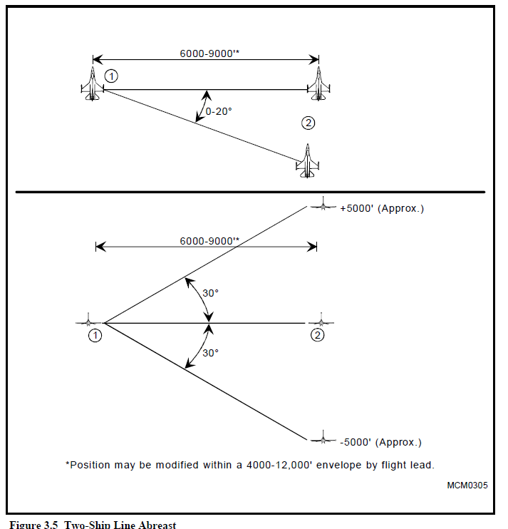

#### **WEDGE**

Wedge is defined as the wingman positioned from 30° to 60° aft of the leader's 3/9 line, 4000' to 6,000' back (Figure 3.6). The advantages of wedge are that the leader is well protected in the 6 o'clock area and is free to maneuver aggressively. The wingman may switch sides as required during turns. He may also switch sides as required to avoid terrain, obstacles or weather but must return to the original side unless cleared by the leader. The flight lead may extend the formation spacing to 12,000' to meet particular situations or requirements.

The most significant disadvantage of the wedge is that it provides little to no six o'clock protection for the wingman. Lead changes, if required, are difficult to execute.

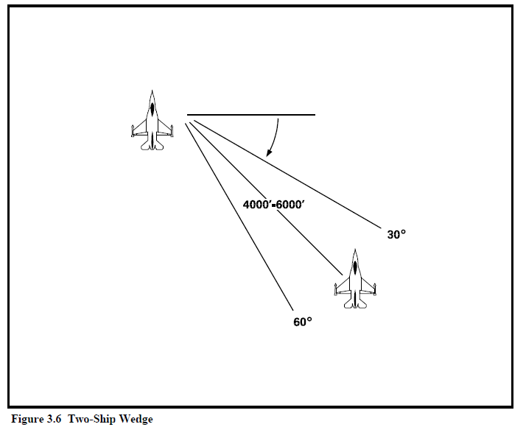

#### **FIGHTING WING**

This formation, flown as a two-ship, gives the wingman a maneuvering cone from 30° to 70° aft of line abreast and lateral spacing between 500' to 3000' (Figure 3.7). Number two maneuvers off lead with cutoff as necessary to maintain position. This formation is employed in situations where maximum maneuvering potential is desired. Arenas for use include holding in a tactical environment or maneuvering around obstacles or clouds. This formation is employed by elements when flying fluid four.

Advantages:

* The formation allows the element to maintain flight integrity under marginal weather conditions or inrough terrain.
* Allows for cockpit heads down time for administrative functions when in a low-threat arena where hard maneuvering is not required.

Disadvantages:

* Poor to nonexistent six o'clock coverage.
* Easy detection of formation by single threat.

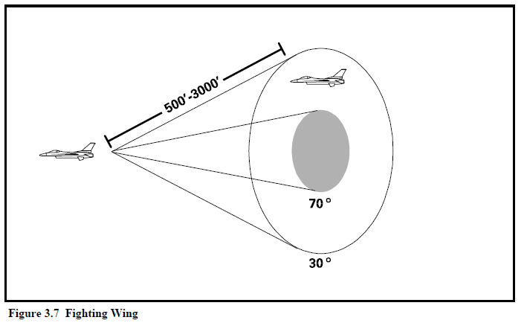

#### **FOUR SHIP FORMATIONS**

The four-ship is under control of one flight lead and is employed as a single entity until such time as it is forced to separate into two elements. At no time should an element sacrifice element integrity

attempting to maintain the four-ship formation. Each two-ship element should have its own radar and visual plan so that no changes will be required if the four-ship is split into two-ships.

#### **BOX/OFFSET BOX**

In the box formation, elements use the basic line abreast two-ship maneuvering and lookout principles. The trailing element takes 1.5 to 3 NM separation, depending on terrain and weather. The objective of the spacing is to give maximum separation to avoid easy visual detection of the whole formation, while positioning the rear element in a good position to immediately engage an enemy converting on the lead element. Because the F-16 is difficult to see from a direct trail position, a slight offset will facilitate keeping sight of the lead element (Figure 3.8). Use of air-to-air (A-A) TACAN between the elements, and the radar in the rear element, will help keep the proper spacing. However, proper emission control may preclude their use in combat. The arrowhead variation makes number two's formation easier, freeing him for more lookout (Figure 3.9). NOTE: In an ATC environment, the trailing element should fly 1 NM or less if standard formation is required. Formation maneuvers are initiated by element leaders. Number three maneuvers to achieve prebriefed spacing on the lead element (based on threat, mission, weather, etc.).

Advantages:

* The formation provides excellent mutual support and lookout.
* The rear element is positioned to engage an adversary making a stern conversion on the lead element.
* It is difficult to visually acquire the entire flight.
* Element spacing for an attack is built into the formation.

Disadvantages:

* The formation is difficult to fly in poor visibility and rugged terrain.
* Depending on position, the trailing element may be momentarily mistaken as a threat, especially if staggered too much off to one side.

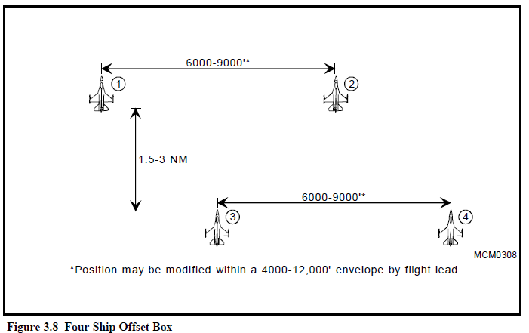

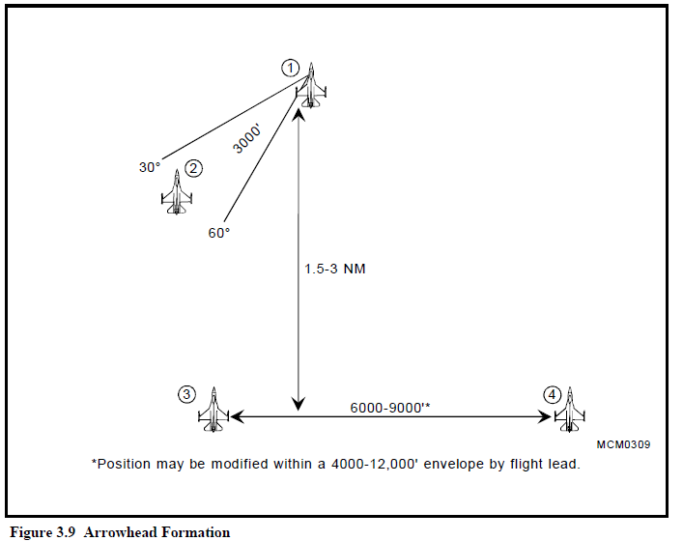

#### **WEDGE**

Elements are in two-ship wedge with the trailing element lead 1.5 - 3 NM back, offset as required to

maintain visual (Figure 3.10). Number two flies off of number one, maneuvering with cutoff as necessary to maintain position. Number three flies off of number one, maneuvering as required to maintain visual. Number four flies off of number three.

Advantages:

* Very offensive for air-to-air threats forward of the 3/9 line.
* Inexperienced wingmen may find it easier to maintain a visual on lead and stay in formation.
* The formation permits four aircraft to maintain flight integrity under marginal weather or extremely rugged terrain conditions.

Disadvantages:

* Six o'clock lookout may be poor.
* Formation easily detected by single threat.
* The defensive maneuvering flexibility of the flight is very limited.
* Number two must be disciplined and fly no further than 6,000 feet from lead to avoid conflict with trailing element.

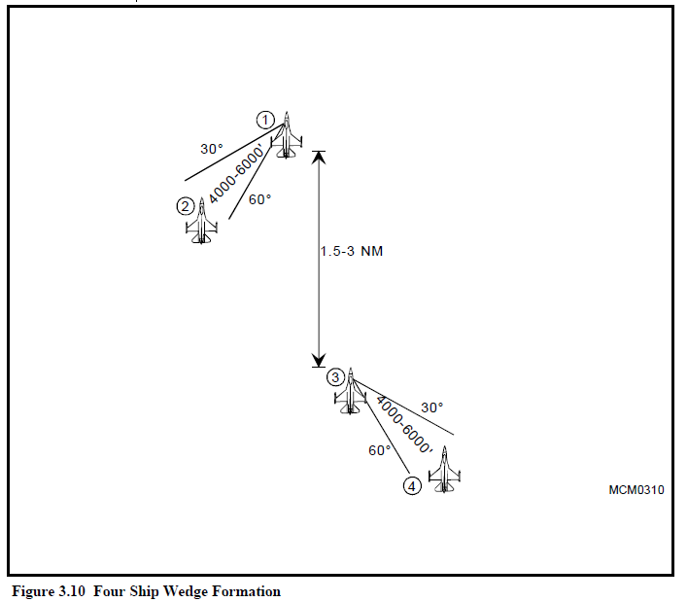

#### **FLUID FOUR**

Element leads maintain line abreast formation, while wingmen assume fighting wing (Figure 3.11).

Number three maneuvers off number one as if in line abreast. Number two and number four maneuver off their element leaders to maintain the outside of the formation. Element leads are responsible for deconfliction of elements when crossing the opposing element's six o'clock.

Advantages:

* Inexperienced wingmen are kept close for ease of maneuvering.
* Four-ship maneuverability is good.
* Formation provides concentration of force.
* Easily converts to three-ship when one aircraft falls out.

Disadvantages:

* Adversary can acquire all four aircraft.
* Defensive maneuvering rapidly becomes confusing due to the proximity of aircraft.
* Cumbersome to maneuver at low altitude in rough terrain.

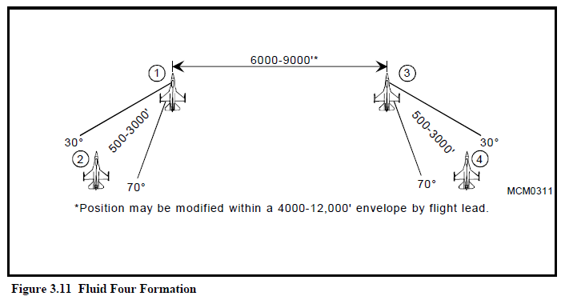

SPREAD FOUR

Element leads maintain the same spacing as for fluid four, but wingmen position themselves 0º to 30° back from their element leads and 6000' to 9000' spread (Figure 3.12). Increased lateral spacing for wingmen facilitates maneuvering. Each element uses fluid maneuvering. Number three flies off number one. The elements are not always required to be line abreast. On some occasions they may be briefly in trail.

Advantages:

* Spread formation makes it difficult for an adversary to visually acquire the entire flight at once.
* Firepower is maximized for BVR weapons employment.

Disadvantages:

* Maneuvering is difficult if the line abreast position is maintained.
* Very difficult for wingmen to fly at low altitude.

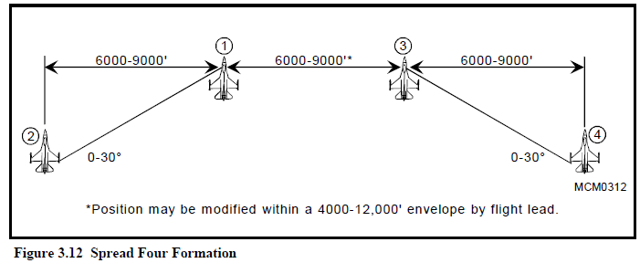

#### **THREE SHIP FORMATIONS**

There may be occasions when a priority mission requires maximum available aircraft and a three-ship is the only alternative. Mutual support requirements to ensure survivability and recovery are paramount; therefore, a three-ship contingency should be briefed on all four-ship missions. On these occasions, the following three-ship formation discussion is applicable.

Responsibilities:

* Number One—navigation, then radar and visual lookout.
* Number Two—visual and radar lookout, back-up navigation.
* Number Three—visual, then radar lookout.

**Vic Formation**

This is basically the arrowhead four-ship without number two (Figure 3.13). The lead aircraft

maneuvers as desired. The trailing element uses line abreast maneuvering to follow.

**Wedge**

This is the same as four-ship wedge without number four.

**Fluid Three**

This is the same as fluid four with one airplane missing. If the three-ship is caused by one aircraft

falling out from a briefed four-ship, the following position changes should be followed: if lead falls out, number three assumes lead and number two moves to line abreast; if number three falls out, number four moves up to line abreast; if number two or four fall out, there are no changes.

**Three-Ship Spread**

This is the same as spread four with one aircraft missing. Roles and responsibilities caused by fall out

from a four-ship are the same as fluid three.

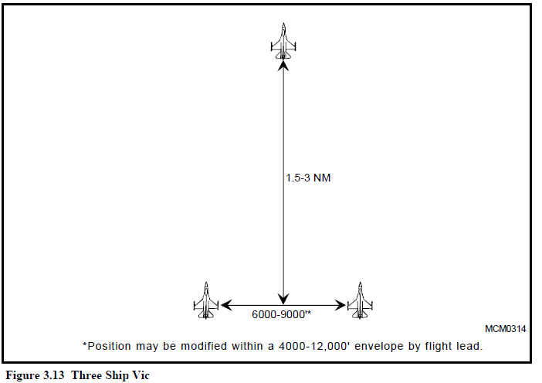

### TURNS

#### **CHECK TURN**

A 30° check turn while in line abreast formation will be directed with the call *”Check Left/ Right"*

or *”Check Left / Right heading".*

The turn will start immediately when the last pilot responds with their flight number.

Both aircraft initiate the turn simultaneously to maintain a 30° bank.

The inside aircraft turns an additional 30° then turns back to re-establish the 1 NM spacing. This snaking

manoeuvre prevents the inside pilot from moving ahead and breaking the line-abreast formation.

The throttle must be used to ensure airspeed remains constant throughout the manoeuvre.

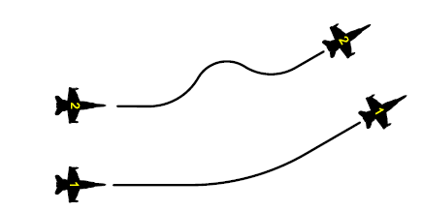

#### **TACTICAL TURNS**

The line abreast formation compensates for its inherent maneuvering problems with specialized prebriefed procedures. These include the type of turns to be made, the parameters at which these turns will be made, and the method by which these turns will be initiated. The parameters for the turns can be briefed by each flight lead and usually consist of the speed, "G", and the power required in the turn. The method of turn initiation is generally by radio call, wing flash, or check turn.

When flying spread formation (line abreast) manoeuvring needs to be standardized and prebriefed. Flight members need to know the type of turn, the parameters at which the turns will be made and the method these turns are initiated. As such we have tactical turns contracts as part of our standard procedures:

- Both aircraft will perform the turn by performing an energy sustaining turn.

- An energy sustaining turn is a level turn conducted at full military power using ”G” to maintain airspeed.

- After the turn is complete the throttle is returned to it's position before the turn commenced. The airspeed and altitude before, during, and after the turn must remain constant.

The following procedure is required:

- Set your throttle to FULL MIL, then;

- Bank and pull to maintain a level turn at exactly the contract speed (for example 350 knots), then;

- At your new heading roll out back to level, then;

- Return the throttle to the position it was before the turn and ensure you are still at your briefed speed.

Turns are initiated on radio by the flightlead, and must be acknowledged by wingmen.

It is very important that wingmen maintain good initial spread formation on flightleads. Any formation error before the turn will result in a larger error after the turn most of the time. An inexperienced wingman spread aft of flightlead before a cross turn into a CAP will end up in spread forward after the turn. Wingmen should strive to get back to a perfect spread formation outside of the turns. Do not overcorrect during the turns by varying your speed. Stay on contract and alter formation in time (when turn is initiated) or on straight legs.

#### **HOOK TURN**

A hook turn allows the fight to reverse their direction while maintaining their tactical formation and offset to the right or left in the process.

The turn will start immediately when the last pilot responds with their flight number.

Both aircraft initiate a simultaneously level energy sustained turn which continues until the airframe is pointing in the reciprocal direction.

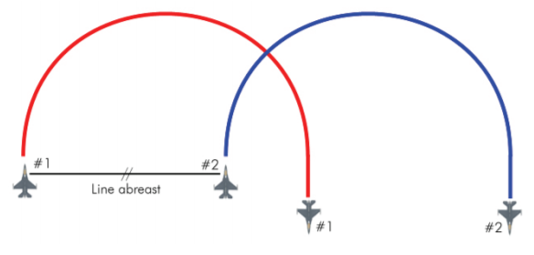

#### **CROSS TURN**

A cross turn allows the fight to reverse their direction while maintaining their tactical formation.

The turn will start immediately when the last pilot responds with their flight number.

Both aircraft initiate a simultaneous level energy sustained turn which continues until the airframe is

pointing in the reciprocal direction.

Note that because this turn typically starts 1 nm apart the aircraft are turning into each other. As the

radius of a 180° energy sustaining turn has a much larger radius the aircraft will be substantially further than 1nm apart after the turn. Therefore both aircraft should continue the turn for an additional 30°, and then turn back to the desired heading once their separation gets to 1.4nm to settle on the original heading at 1nm.

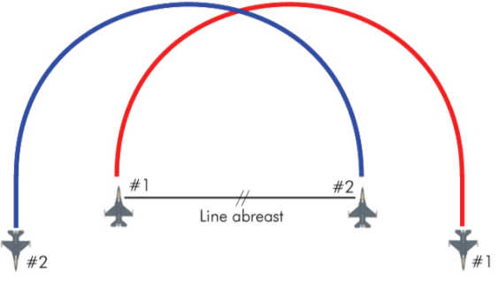

#### **90° tactical turns**

A 90° tactical turn while in line abreast formation will be directed with the call ”TAC Left / Right” or

”TAC Left / Right heading”.

The turn will start immediately when the last pilot responds with their flight number.

The pilot that is turning into their wingman initiates the turn by turning first

When turning away from the wingman the pilot will watch the other airframe begin it's turn and then initiate their own turn when the other airframe's nose is pointing directly at them.

Both aircraft will complete the turn by performing an energy sustained turn.

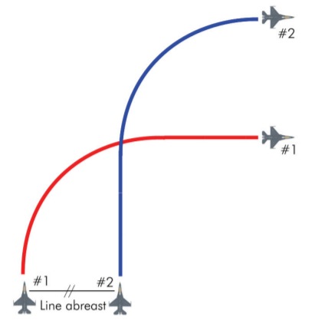

#### **45° tactical turns**

A 45° tactical turn while in line abreast formation will be directed with the call ”TAC Left / Right 45” or ”TAC Left / Right heading”.

The turn will start immediately when the last pilot responds with their fight number.

The pilot that is turning into their wingman initiates the turn by turning first

When turning away from the wingman the pilot will watch the other airframe begin it's turn and then initiate their own turn when the other airframe passes their 6-o'clock position.

Both aircraft will perform the turn by performing an energy sustained turn

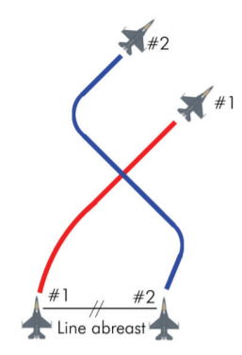

#### **PITCH BACK**

The pitch back is related to the energy sustaining turn except that it uses a nose high attitude in the turn to gain altitude while turning.

When performing a pitch back energy is either lost or spent more slowly meaning the turning circle will be wider or airspeed will be lower after the manoeuvre. This will require the wingman to perform some extra work returning to position.

The lead pilot should cover how this manoeuvre is expected to be performed during the pre-flight briefing.

#### **SLICE BACK**

The slice back is related to the energy sustaining turn except that it uses a nose low attitude in the turn to trade altitude for airspeed while turning and is usually done defensively when airspeed is critical.

When performing a slice back altitude is converted to airspeed and the turning circle will be affected by the manoeuvre. This will require the wingman to perform some extra work returning to position.

The lead pilot should cover how this manoeuvre is expected to be performed during the pre-flight briefing.

## TAC-02: **DEFENSIVE SYSTEMS AND MANOEUVRES** (SQ)

## TAC-03: **NIGHT OPERATIONS** (SQ)

## TAC-04: **AWACS COMMUNICATIONS** (SQ)

## SAT-01: **HIGH AND MEDIUM ALTITUDE DELIVERIES** (SQ)

## SAT-02: **LOW ALTITUDE DELIVERIES** (SQ)

## ACT-01: **ACM 1v1 WVR MANOEUVRING** (IP)

## ACT-02: **BVR ENGAGEMENTS AND MUTUAL SUPPORT** (IP)

## TAC-05: **MISSION QUALIFICATION TRAINING CHECKOUT** (IP)

# **CONTINUATION TRAINING** (CT)

## ACT-03: **DCA CAP** (SQ)

## ACT-04: **OCA SWEEP**(SQ)

## ACT-05: **OCA ESCORT** (SQ)

## SAT-03: **SAT FLIGHT LEAD**(SQ)

## SAT-04: **ARMED RECONNAISSANCE**(SQ)

## ACT-06: **DCA INTERCEPT**(SQ)

## SAT-05: **CLOSE AIR SUPPORT**(IP- CAS INSTRUCTOR)

## SAT-06: **SCAR**(SQ)

# **UPGRADES** (UGT)

## SAT-07: **FLUG 2-SHIP: OPPOSED SAT** (IP)

## ACT-07: **FLUG 4-SHIP: DCA CAP** (IP)

## SAT-08: **FLUG 4-SHIP: OPPOSED SAT** (IP)

## ACT-08: **MISSION COMMANDER UPGRADE: DCA CAP** (IP)

## SAT-09: **MISSION COMMANDER UPGRADE: SAT AI** (IP)

## SAT-10: **FORWARD AIR CONTROLLER (AIRBORNE)** (IP- CAS INSTRUCTOR)

# TO BE ADDED LATER

* IP
* AGGRESSOR

# **TERMS**

|  |  |  |
| --- | --- | --- |
| Term | meaning |  |
|  |  |  |
|  |  |  |
|  |  |  |
| ACT | Air Combat Tactics |  |
| AI | Air Interdiction |  |
| AR | Armed Reconnaissance |  |
| BVR | Beyond Visual Range |  |
| CAP | Combat Air Patrol |  |
| DCA | Defensive Counter Air |  |
| FLUG | Flight Lead Upgrade |  |
| OCA | Offensive Counter Air |  |
| SAT | Surface Attack Tactics |  |
| SCAR |  |  |
| WVR | Within Visual Range |  |
| mdc | Mission Data Card | A standardised card with all critical mission information, such as frequencies and flightplan. |
| kcas | Knots Calibrated Air Speed |  |
| 3/9 line |  |  |